OCEAN FISHERY DEPENDENCE, POVERTY AND INEQUALITY NEXUS: MICRO LEVEL EMPIRICAL EVIDENCE FROM THE COASTAL
LOWLANDS OF KENYA

SOMOEBWANA MOHAMED IDRISS

A Thesis Submitted to the Graduate School in Partial Fulfillment of the Requirements for the Master of Science Degree in Agricultural and Applied Economics of Egerton University

EGERTON UNIVERSITY

MAY, 2021

DECLARATION AND RECOMMENDATION
Declaration
I hereby declare that this thesis is my original work and has never been submitted to any institution for academic purposes for the award of any academic certificate, diploma or degree.

Signature……… Date…17/05/2021…………
Somoebwana Mohamed Idriss
KM17/12130/17

Recommendation
This thesis has been submitted with our approval as Egerton University supervisors.

Signature……………. Date…21/05/2021………….
Dr. Oscar Ingasia Ayuya, PhD
Department of Agricultural Economics and Agri-Business Management,
Egerton University

Signature….. Date…21/05/2021…………..
Dr. John Momanyi Mironga, PhD
Department of Geography,
Egerton University

COPYRIGHT
©2020 Idris Somoebwana Mohamed
All rights reserved. No part of this thesis may be reproduced, transmitted or stored in any form or means such as electronic, mechanical or photocopying including recording or any information storage and retrieval system, or translated in any language, without prior written permission of the author or Egerton University on that behalf.

DEDICATION
I dedicate this work to my parents; Idriss Somoebwana and Joria Mzee, and my siblings; Mzee, Somoebwana, Fatma, Rahma and Aisha for their moral support and commitment towards the accomplishment of this work.

ACKNOWLEDGEMENTS
I would like to acknowledge my gratitude to Egerton University and particularly the entire staff of the Department of Agribusiness management and Agricultural Economics under the leadership of Prof. Patience Mshenga for their incessant support throughout my studies. I would also like to sincerely thank African Economic Research Consortium (AERC) for funding my master programme and the research under study. Further, much gratitude also goes to the Collaborative Masters of Agricultural and Applied Economics (CMAAE) secretariat for their support to undertake electives and specialized training at the University of Pretoria in South Africa.
Special thanks go to my supervisors, Dr. O.I. Ayuya, and Dr. J.M. Mironga, for their undying support and guidance. Most importantly, I wish to thank them for their commitment and invaluable advice from orientation to the successful completion of this study. I also affirm my acknowledgement to the course lecturers for their helpful insights in a wide range of subjects that nurtured my critical thinking.
I am also thankful to my fellow colleagues for their support through advice and information sharing in various stages of my study. Additionally, I would like to acknowledge chairpersons of Beach management units and residents of Kilifi County for the guidance, support and cooperation during data collection, Moreover; many thanks are also attributed to all the enumerators who took part in the process of data collection of this research. Finally, my special thanks go to Almighty God for the love, guidance, mercy and care during the entire study period.

ABSTRACT
Kenya’s ocean fishery resource offers livelihood options and a source of income to poor rural households. Although the resources have the potential to alleviate poverty and inequality higher dependence can perpetuate poverty. Poverty and inequality remain development concerns and have been at the forefront of policy agendas worldwide. However, the effort has been compromised by environmental degradation, poor infrastructure, and inadequate institutional support, particularly in Kilifi County. Therefore, the study sought to contribute to the achievement of blue economy sub-themes such as poverty eradication, inclusive economy, food security and managing and sustaining marine life through sustainable dependence and livelihood among households in Kilifi County, Kenya. Multi-stage sampling technique was used to collect data from 384 households. Primary data was obtained through structured pretested questionnaires administered by trained enumerators. Data was analyzed using both SPSS and STATA packages. Descriptive statistics was employed to determine the livelihood options among households. Results indicated that ocean fishery and related activities is the highest livelihood option with participation rate of approximately 68% exhibiting gender differences. Ocean fishery and related activities is a male dominated livelihood option; however, females were more than a half in fish trading and small scale processing since it required low capital and unskilled labour. Fractional response model was also used to determine factors affecting ocean fishery dependence. Education level, agricultural productive assets, access to credit, group membership, security tenure, flood, and fish price were found to significantly influencing ocean fishery dependence. Further, multi-dimension poverty indices were estimated and later multivalued treatment effect approach was used to determine the effect of ocean fishery dependence on the indices. The households were classified on non-dependency, low dependency and high dependency and were approximately 32.0%, 18.0% and 50.0% respectively. The results revealed that there were significant differences between different dependence levels in each welfare outcome, a finding that would not have been obtained by binary treatment effect methods. The results also indicated that increasing ocean fishery dependence increased multi-dimension poverty indices among dependent households. The study, therefore, recommends a clear stakeholder mapping coupled with the effective institutional and regulatory framework to enhance sustainable ocean fishery dependence that will contribute to the achievement of blue economy approach.

TABLE OF CONTENTS
DECLARATION AND RECOMMENDATION ii
COPYRIGHT iii
DEDICATION iv
ACKNOWLEDGEMENTS v
ABSTRACT vi
LIST OF TABLES ix
LIST OF FIGURES x
LIST OF ABBREVIATIONS AND ACRONYMS xi
CHAPTER ONE 1
INTRODUCTION 1
1.1 Background of the study 1
1.2 Statement of the problem 3
1.3 Objectives of the study 4
1.3.1 General objectives 4
1.3.2 Specific objectives 4
1.4 Research questions 4
1.5 Justification of the study 4
1.6 Scope and limitations of the study 5
1.7 Operational definition of terms 6
CHAPTER TWO 7
LITERATURE REVIEW 7
2.1 Ocean dependence activities and livelihood options 7
2.2 Determinants of ocean reliance 8
2.3 The concept of poverty, inequality, and welfare 10
2.3.1 Natural resource dependence and welfare 11
2.4 Gaps in the literature review 14
2.5 Theoretical framework 16
2.6 Conceptual framework 17
CHAPTER THREE 19
METHODOLOGY 19
3.1 Study area 19
3.2 Research design 21
3.3 Sampling procedure and sample size 21
3.4 Data collection and analysis 22
3.5 Analytical framework 22
3.5.1 Measuring poverty 25
3.5.2 Measuring inequality 27
3.5.3 Econometric analysis on the effect of ocean fishery dependence on multi-dimension poverty indices 29
3.6 Ethical consideration 34
CHAPTER FOUR 35
RESULTS AND DISCUSSION 35
4.1 Determination of livelihood options among households 35
4.1.1 Ocean fishery dependence among households in Kilifi County 39
4.2 Factors influencing the level of ocean fishery dependence 40
4.2.1 Diagnostic test of the variables used in the econometric analysis 41
4.2.2 Fractional response model results on factors influencing ocean fishery dependence 43
4.3 Effect of ocean fishery dependence on poverty and inequality 46
4.3.1 Inequality measure on the ocean fishery dependency 48
4.3.2 Econometric analysis on the effect of ocean fishery dependence on poverty and inequality 51
4.3.3 Heterogeneous treatment effect on the ocean fishery dependency 55
4.3.4. Dose response function 60
CHAPTER FIVE 63
CONCLUSION AND RECOMMENDATIONS 63
5.1 Conclusions 63
5.2 Recommendations 63
5.3 Areas for further research 64
REFERENCES 66
APPENDICES 80
Appendix I: Questionnaire 80
Appendix II: Tests on Endogeneity and the Validity of the Selected Instrumental Variables 84
Appendix III: Multivalued Treatment Effect Model 85
Appendix IV: Research Permit 89
Appendix V: Publication Abstract Page 91

LIST OF TABLES
Table 3.1: Distribution of sample size 22
Table 3.2: Variables used in the fractional response model 24
Table 3.3: Dimensions and indicators of the multidimensional poverty index 26
Table 3.4: Variables used in the Gini coefficient 28
Table 4.1: Livelihood options among households in Kilifi County 35
Table 4.2: Percentage of ocean fishery and related activities by gender 36
Table 4.3: General differences between dependent and non-dependent households in Kilifi County 37
Table 4.4: Income share from different livelihood options by means 39
Table 4.5: VIF test results for continuous variables 41
Table 4.6: Contingency coefficient test for categorical variables 42
Table 4.7: Test for heteroskedasticity 42
Table 4.8: Fractional response model results on factors influencing ocean fishery dependence 43
Table 4.9: Descriptive statistics of multidimensional poverty indices 47
Table 4.10: Inequality across dependency levels 49
Table 4.11: Gini decomposition by income source 49
Table 4.12: Multivalued average treatment effect (ATE) of treatment level m relative to treatment l (EIE) 54
Table 4.13: Quantile treatment effect of moving from l to m (EIE) 56

LIST OF FIGURES
Figure 2.1: Conceptual framework 18
Figure 3.1: Map of the study area, Kilifi County 20
Figure 4.1: Lorenz curves for household income with and without ocean fishery income 50
Figure 4.2: Conditional densities for probability of treatment on non-dependency category 52
Figure 4.3: Conditional densities for probability of treatment on low dependency category 52
Figure 4.4: Conditional densities for probability of treatment on high dependency category 53
Figure 4.5: Full pairwise comparison of average treatment effect (ATE) with 95% CIs 57
Figure 4.6: Average treatment effect comparisons in the 25th percentile with 95% CIs 58
Figure 4.7: Average treatment effect comparisons in the 50th percentile with 95% CIs 58
Figure 4.8: Average treatment effect comparisons in the 75th percentile with 95% CIs 59
Figure 4.9: Dose response function and corresponding marginal treatment effect estimates on MPI 60
Figure 4.10: Dose response function and corresponding marginal treatment effect estimates on Household poverty score 61
Figure 4.11: Dose response function and corresponding marginal treatment effect estimates on per capita income 61

LIST OF ABBREVIATIONS AND ACRONYMS
AERC African Economic Research Consortium
AIC Akaike Information Criterion
ATE Average Treatment Effect
BIC Bayesian Information Criterion
BMU Beach Management Unit
CGOK County Government of Kilifi
CIA Conditional Independence Assumption
CIS Confidence Intervals
DRF Dose Response Function
EIE Efficiency Influence Estimator
ESR Endogenous Switching Regression
FAO Food and Agriculture Organization of the United Nation
FGT Forster-Greer-Thorbecke poverty index
FRM Fractional Response Model
GLM Generalized Linear Model
GOK Government of Kenya
GPS Generalized Propensity Score
IPW Inverse Probability Weighted Treatment
LEF Linear Exponential Family
MPI Multidimensional Poverty Index
OLS Ordinary Least Square Method
POM Potential Outcome Means
QML Quasi Maximum Likelihood
QTE Quantile Treatment Effect
RA Regression Adjustment
SDGs Sustainable Development Goals
SPSS Statistical Package for Social Sciences
SUTVA Stable Unit Treatment Value Assumption
VIF Variance Inflation Factor

CHAPTER ONE

INTRODUCTION

1.1 Background of the study
The contribution of natural resources to household livelihood is well recognized and documented (Funge‐Smith & Bennett, 2019; Gunatilake, 2007; López-Feldman et al., 2011; Nguyen et al., 2020). Natural resources provide a wide range of products, such as timber and fish, which serve as essential means of livelihood for the poor (Nguyen et al., 2015; Damania et al., 2020). Marine resources contribute to food security, livelihood, and mitigation of climate change through temperature regulation as well as enhanced economic growth through trade (Andriesse et al., 2019; Morzaria-Luna, 2013). In Kenya, the annual economic value of marine resources contributes to over US$4.4 billion to GDP (Muigua, 2018).
In particular, Kilifi County landed a marine fishery output of US$5.54 million in 2017 and provided employment to approximately 7,284 traders and fishers (CGOK, 2018). This signifies the vast potential in the sector that can sustain the livelihoods of the local communities and, therefore, contribute to poverty decline, food security, and the country’s GDP. However, low adoption of fishing technology, pollution, low-value addition, and intrusion of salt mining companies have contributed to low production of the sector (CGOK, 2018). Literature shows that natural resources have the potential to alleviate poverty, but over-dependence can perpetuate poverty (Lopez-Feldman et al., 2007). It is likely that higher dependence limits the livelihood strategies to cope with economic shocks as it restricts both social and material well-being (Edirisinghe, 2015).
The paradox of poverty in resource dependence has well been acknowledged, especially in the fishery (KC et al., 2019; Stanford et al., 2013). A conventional narrative in development is that the poor serves as both the victims and agents of environmental degradation (Soltani et al., 2012; Soltani et al., 2014). As such economic theory argues that there is a lack of cooperation in the management and sustenance of common-pool resources (Fehr & Leibbrandt, 2008; Ostrom & Hess, 2010; Velez et al., 2009). Therefore, the vicious cycle of poverty, environmental degradation, and population growth is likely to prosper in this case. However, this is not likely to be the case in Kilifi County as marine resource output is below its potential since the estimated maximum sustainable yield biomass is approximately 15 times higher than the current marine catches (FAO, 2016; Muigua, 2018; Van Hoof & Steins, 2017). Failure to value education due to the fishery dependence, bureaucratic policies, volatile international market, and vulnerability to anthropogenic stressors such as pollution is likely to hamper the small-scale fishery operations in underexploited zones (Funge‐Smith & Bennett, 2019; Morzaria-Luna, 2013; Stanford et al., 2013).
Poverty and inequality in materials deprivation remain a development challenge for most rural households (Edirisinghe, 2015). According to FAO (2013), 12% of the world population in 2011 experienced acute hunger, and the majority of them were in rural areas of the developing countries. Agriculture and other natural resource activities such as fishing are the cornerstone in rural economies (Martin & Lorenzen, 2016). In Kilifi County, poverty and inequality in material deprivations are extreme due to low agricultural productivity due to insufficient technological uptake, lack of employment opportunities, high illiteracy, and population growth rate, inadequate infrastructure, landlessness, and poor institutional support. The county has an absolute poverty level of 71.7%, which is higher than the national poverty level of 45.2% and hence provides a clear indication of underdevelopment in the region (CGOK, 2013).
Fisheries resources have the potential to alleviate poverty and promote food security; but, they are often equated to poverty mainly due to the poverty-environment trap (Satumanatpan & Pollnac, 2020; Stanford et al., 2013). The trap is concerned with dependence and vulnerability, which is higher among the poor compared to the non-poor (Langat et al., 2016; Nguyen et al., 2018). The water resource potential in reducing poverty and inequality and promoting household welfare is increasingly being recognized, and Kenya has begun to embrace the concept of the sustainable blue economy being the host to the first global conference on the sustainable blue economy, which was held in Nairobi in November 2018.
Over the previous decades, the Kenya coastal population has increased rapidly. Estimates show that Kilifi County has a population growth rate of 3.05%, which is higher compared to the national population growth rate of 2.03% (Ngugi et al., 2013). This has put substantial pressure on the marine resource given that fishery and related activities are the major economic activities in the region. Most artisanal fishers along the coastal region of Kenya are poor, live in marginal areas, and have a lower adaptive capacity (Allan-Degen et al., 2010). With studies reporting lower willingness of fishers to exit fishing amid a decline in catch abundance (Daw et al., 2012), the dependent households are more likely to be trapped in a poverty-marine fishery trap. Therefore, there is the need to explore the effect of marine fishery dependence on poverty and inequality to develop effective policy recommendations for sustainable marine fishery dependence. This will be vital in contributing to the achievement of sustainable development goals, including poverty eradication, food security and nutrition, and sustainable use of marine resources (United Nations, 2015). More so, the information obtained in this study will significantly contribute to the attainment of the blue economy approach.
The blue economy approach envisions inclusive economic growth and sustainability of marine resources along the coastal region in Kenya (Ahmed &Thompson, 2019; Van Hoof & Steins, 2017). It also envisions the enhancing the coastal communities’ adaptive capacity and preventing socio-ecological trap through participatory decision making (Watson et al., 2016). More so, the blue economy revolves around small scale fishers to promote food security, sustainability and development through a right based approach (Spalding, 2016). As a result, the wealth generated from fishery can contribute to rural development through fishing proceeds and employment multiplier effects due to the commercialized aspect of fish (Béné et al., 2007). Generally, environmental income accounts for the principal share of the rural households’ income (Angelsen et al., 2014). Based on this background, the study aimed at building a strong foundation on the economic value of ocean-dependent activities to poor household welfare and its impact on the alleviation of poverty and inequality.

1.2 Statement of the problem
As the Kenyan coastal population increases, the availability of agricultural land struggles to keep up with its demand. As a result, the importance of the marine resource base for sustainable development and income generation for the households to meet their basic needs has increased. The shift has its implications on the fish biomass concerning both the incidental and target catch. Ocean fishery resources may reduce poverty and inequality. However, over-dependency on marine resources may make households vulnerable to poverty. The common-pool and open-access nature of ocean fishery in Kilifi County in Kenya attract more people hoping to improve their livelihoods. However, little evidence exists on the link between ocean fishery dependence, poverty, and inequality of households in Kilifi County. As such, previous studies in the area have focused on marine resource opportunities and the status of poverty and inequality. Therefore, the study was geared towards exploring the link between ocean fishery dependency and poverty and inequality in order to draw policy recommendations to support the achievement of the blue economy through sustainable livelihood dependence.

1.3 Objectives of the study

1.3.1 General objectives
The study aimed at contributing to the achievement of blue economy sub themes through sustainable ocean fishery dependence and livelihood among households in Kilifi County, Kenya.

1.3.2 Specific objectives
- To determine livelihood options for households in Kilifi County, Kenya
- To determine factors influencing the level of ocean fishery dependence among households in Kilifi County, Kenya
- To determine the effect of ocean fishery dependence on poverty and inequality among households in Kilifi County, Kenya.

1.4 Research questions
- What are the livelihood options for households in Kilifi County?
- What are the factors influencing the level of ocean fishery dependence among households in Kilifi County?
- What is the effect of ocean fishery dependence on poverty and inequality among households in Kilifi County?

1.5 Justification of the study
The study explored ocean fishery dependence and its impact on poverty and inequality with the aim of promoting households’ welfare through sustainable livelihood options. As a result, it is consistent with Kenya’s sustainable blue economy approach and vision 2030 aimed at enhancing food security through a sustainable, inclusive and advanced economy (CGOK, 2018; Muigua, 2018). The study also coincides with the Kenya food and nutrition policy that aims to alleviate poverty given that 7.5 million Kenyans live in extreme poverty (GOK, 2011). Further, studies on natural resource dependence and welfare impact have failed to consider the heterogeneity in effect. For social policy and program planners, unraveling heterogeneity in effect is important as it will give them insights of developing targeted interventions. To bridge this gap, the multivalued treatment effect model was used in this study. The model revealed not only the heterogeneous treatment effect on the ocean fishery dependence, but also the significance differences between dependence levels, as well as the impact of ocean fishery dependence on poverty and inequality.
The analysis of the households’ welfare implication of the extraction of marine resources will enable the establishment of the effective measures and policies to improve the living standards of the households through the transition to more efficient resource use. In this regard, the research will enable the attainment of the three goals of the sustainable development goals (SDGs) which include poverty eradication, food security and nutrition, and sustainable use of marine resources, pioneered towards achieving sustainable growth by the year 2030 (United Nations, 2015). Furthermore, despite the exploitation of the importance of natural resource extraction on poverty and inequality, the intended area of study was yet to be exploited. The study will also contribute extensively to the existing literature concerning households’ response to shock and marine resource extraction, as well as the link between environmental income and dependence.

1.6 Scope and limitations of the study
This study was carried out in Kilifi County in Kenya, targeting households along the Indian Ocean. It captured information regarding the dependence activities, factors affecting the dependence, and its link to household welfare. However, the research was only limited by poor records among households head, but the study relied on thorough probing to assure the quality of data collected.

1.7 Operational definition of terms
Blue economy: The use of marine resources for sustainable and inclusive economic growth.
Fishery dependence: refers to the share of a household’s total income that comes from the ocean fishery resource. It was measured by dividing income from marine resource less associated expenditure and the total household income less total expenditure.
Vulnerability: The extent to which a household is susceptible and incapable of coping with shocks.
Household income: refers to the total amount of money earned by the household by exchanging products or providing services. It involves a summation of income from crops (value of crop produce less cost of inputs), net fisheries-related income and livestock income (sum of income obtained from selling of live animals less cost incurred in purchasing live animals and inputs), household members’ wages and salary, remittances and business income (Mathenge et al., 2010).
Income poverty: failure to satisfy basic needs using per capita income as a threshold.
Multidimensional Poverty: refers to deprivation in human life dimensions such as health, living standard, and education. Three indices were determined to measure multidimensional poverty; household poverty score, multidimensional poverty dummy, and multidimensional poverty intensity.
Welfare: implies command over commodities vis-à-vis income and consumption.
Inequality: implies a difference in material deprivations between different households. It was measured using separate inequality measure and positive multiple of variance across the household poverty scores.
Capability: the ability to achieve.
Sustainable development: Improvement of the welfare of the society over a period of time without compromising the ability of the future generation to meet their needs.

CHAPTER TWO

LITERATURE REVIEW
This section presents the literature of past studies on natural resource dependence and its impact on the household’s welfare. More specifically, the concept of ocean fishery dependence and related activities and their potential contribution to poverty and inequality were explored. Further, possible socio-economic and institutional factors, as well as climatic and idiosyncratic shocks, were investigated to determine their influence on ocean fishery dependence. The reviews were critical for the identification of knowledge gaps that the study sought to bridge. The Sen’s functioning and capability framework, which underpins this study, was also reviewed, and a conceptual framework was presented.

2.1 Ocean dependence activities and livelihood options
Marine resources contribute to food security, livelihood, and mitigation of climate change, as well as enhanced economic growth through trade (CGOK, 2018; Ding et al., 2017; Funge‐Smith & Bennett, 2019; Satumanatpan & Pollnac, 2020). They also serve as the safety net for the poor, providing nutrition and income, particularly in the period of financial hardships. In addition, they generate employment for millions of coastal inhabitants and nearly one billion people worldwide (Fabinyi et al., 2019; Salas et al., 2019; Teh & Sumaila, 2013). Likewise, the marine fishery is the most critical economic activity for sustaining food security and livelihoods for nearly 12 million people worldwide (Morzaria-Luna, 2013). Therefore, the contribution of marine fishery activities to the national economy is inevitable and multifaceted. Apart from improving food security, they also contribute to the gross domestic product (GDP), boost government revenues, and are the source of hard currency (FAO, 2014).
The marine landing in Kenya is approximately 9000 tonnes per year (Van Hoof & Stein, 2017). Its annual economic value, which estimates at over US$4.4 billion, indicates under exploitation of marine resources (Muigua, 2018). However, it remains one of the dominant economic activities along the coastal region in Kenya (Allan-Degen et al., 2010; CGOK, 2013). In this regard, marine resources generate employment to over two million Kenyans through fishing activities, boat building, fish processing, equipment repair, and tourism (CGOK, 2018; Muigua, 2018). Also, apart from fishing, the residents of the coastal lowlands of Kenya engage in tourism, factory work, and farming, including sports and recreation, cash crop cultivation, palm wine tapping and selling, plaiting makuti, and farm labour. Many coastal residents depend on these marine resources due to their low levels of education and training, landlessness, and the aridity of the climate (Van Hoof & Stein, 2017).
Further, the ocean resource contributes numerous economic activities through its various sectors such as extraction of living and non-living resources, commerce and trade, as well as ecosystem management and protection (Ahmed & Thompson, 2019; The Economist, 2015; Voyer et al., 2015). However, due to distinct challenges facing the sector as a result of its nature of the common property and inadequate management, the need for a multilateral and coordinated approach is essential to ensure effective maritime security. As such, it will enhance the achievement of the blue economy through the protection of property rights, provide oceanographic data, safeguard navigation routes and ensure economic growth and development (Voyer et al., 2015). Apart from the natural resource economic activities, the rural households may diversify their economic activities outside these resources such as animal husbandry, crop production, off-farm wage employment, and off-farm self-employment (Lopez-Feldman et al., 2007; Soltani et al., 2012; Soltani et al., 2014; Stoop et al., 2016). As a result, the households will be able to counteract the adverse impact of shocks on their livelihood wellbeing and at the same time sustain the natural resources (Nguyen et al., 2015; Stanford et al., 2013).

2.2 Determinants of ocean reliance
Small scale fisheries have the potential to alleviate poverty and promote food security; but, they are often equated to poverty mainly due to the poverty-environment trap (Belhabib et al., 2019; Funge‐Smith & Bennett, 2019; Stanford et al., 2013). The trap is concerned with dependence and vulnerability, which is higher among the poor compared to the non-poor (Narain et al., 2008; Nguyen et al., 2018; Soltani et al., 2014). For instance, the small-scale fishers in Kenya are generally poor and depend heavily on the traditional and simple production methods in subsistence agriculture and artisanal fishing, and therefore, more vulnerable to shocks. Also, the artisanal fishery is characterized by uncertainty and depends strongly on seasons, has a low literacy level, and is politically underrepresented because they live in remote and marginal areas. As such, they explore the nearshore resources through fishing, and shrimp trawling, tourism, and wage labour (Allan-Degen et al., 2010). Furthermore, Soltani et al. (2014) found dependence on natural resources is influenced by population density, carrying capacity, and management institutions.
The fishers’ number has been observed to increase gradually in Kenya. This is because of the poverty that is linked to poor education, inadequate employment opportunities, poor agro-ecological conditions, and unfavourable climate (Allan-Degen et al., 2010). In this sense, barriers to livelihoods diversification usually leave the small scale fishers trapped in poverty, for instance, lack of skills, contacts, and access to capital (Cinner et al., 2012). Also, it is likely that the availability of higher biomass may induce the households to extract more natural resources as it increases time efficiency (Narain et al., 2008; Soltani et al., 2014). Moreover, Nguyen et al. (2018) found that education level and age of households’ head, distance to the extracting ground, physical accessibility, asset value, and household ratio significantly affect resource dependence. Therefore, the weak institutional framework to capacitate the rural livelihoods may be the missing link towards diversified and sustainable livelihood options (Nguyen et al., 2015).
Further, the dependence on a specific source of income is as well associated with other socioeconomic characteristics such as wealth, the gender of the head of the household, household size, and ethnicity. In addition, market access, infrastructure, financial capital, access to health, debt, land ownership, and membership to formal or informal institutions are likely to affect the dependence on these resources (Béné & Friend, 2011; Soltani et al., 2012). Hence, given climate variability, institutional bottlenecks, inadequate infrastructure, and land degradation (Abdullai & Issahaku, 2019), the households may be attracted to the fishery resource as a result of both short-term and long-term shocks. These conditions create a downward spiral of overexploitation, which leads to poverty, and poverty results in overexploitation (Lopez-Feldman et al., 2007; Stanford et al., 2013).
Despite the existence of the negative correlation between resource dependency and daily income and consumption per capita (Nguyen et al., 2018), the implication of water resource extraction in the reduction of poverty and inequality and its effort in promoting household welfare is inevitable (Stanford et al., 2013). The viewpoint that has seen Kenya embarks on a sustainable blue economy. In this regard, the blue economy approach will ensure inclusive economic growth and sustainability of marine resources along the coastal region in Kenya (Ahmed & Thompson, 2019; CGOK, 2018; Van Hoof & Steins, 2017). It will also enhance the community’s adaptive capability and prevents socio-ecological trap through participatory decision making (Watson et al., 2016). More so, the blue economy paradigm will revolve around the small-scale fishers to promote sustainability and development through a right-based approach (Spalding, 2016). As a result, the wealth generated from fishery can contribute to rural development through fishing proceeds and employment multiplier effects due to the cash crop nature of fish (Béné et al., 2007).

2.3 The concept of poverty, inequality, and welfare
Over the previous decades, poverty reduction has become a dominant goal in development policy. Initially, the emphasis was on income and consumption; however, the most important development of poverty research was a shift to a more multi-dimensional approach that considered various dimensions of human life (Kakwani & Silber, 2008). Poverty relates to pronounced deprivation in well-being. In this sense, poverty is relative deprivation, and thus the essence of poverty is inequality, which depends on income level and distribution. As such, it is composed of absolute poverty, relative poverty, and poverty lines (Ogbeide & Agu, 2015). Absolute poverty relates to the physiological minima for human survival, while relative poverty indicates a constant proportion of current consumption and mean income. On the other hand, poverty lines entail the minimum level of welfare not to be termed poor (Ravallion, 2010). Therefore, poverty and inequality are a development concern in most developing countries (Ferreira & Ravallion, 2008).
In particular, Kilifi County is considered among the poorest counties in the country, with an absolute rate of poverty of 71.7%. The high incidence of poverty is mainly attributed to low agricultural productivity due to inadequate technology uptake, inadequate infrastructure, frequent natural disasters, population growth, gender inequality in access to productive assets, and high illiteracy level (CGOK, 2013). The County also has an inequality measure of 0.565 and is regarded among the worst in Kenya, caused mainly by the social exclusion of the marginalized communities (Ngugi et al., 2013). However, it has an impressive Human Development Index (HDI) of 0.5807, which is above the national index of 0.561, implying positive development. Implementation of the Kilifi County Integrated plan (CID) will provide essential linkages for the County and National government and facilitation of the vision 2030 and other development agendas towards the eradicating poverty and inequality as well as in achieving broader development goals (CGOK, 2013).
Kilifi County has included the dimensions of the blue economy in its second County Integrated Plan (CID) to embrace mariculture, improve market access, conserve the maritime base, and invest in human capital for a sustainable and inclusive ocean economy (Benkenstein, 2018; CGOK, 2018). The blue economy approach also involves harnessing the potential of lakes and rivers to improve the welfare of all, particularly people in developing states, women, youth, and Indigenous peoples. It is also concerned with leveraging the latest innovations to build prosperity while conserving waters for future generations. Freshwater species have been observed to decline since 1970, for instance, the fishing tragedy being observed in Lake Victoria in Kisumu. Therefore, adequate policies and incentives are essential to promote the sustainable use of water resources and enhance livelihood opportunities by exploiting the blue economy paradigm (Kabubo-Mariara, 2013).

2.3.1 Natural resource dependence and welfare
Natural resource contributions to rural livelihoods have been documented across a wide range of literature (Angelsen et al., 2014; Joos-Vandewalle et al., 2018; Kabubo-Mariara, 2013; Lopez-Feldman et al., 2007; Soltani et al., 2014; ; Walelign & Jiao, 2017; Widianingsih et al., 2016). They serve as an indispensable source of income and subsistence for most households, especially in rural parts of developing countries. They can alleviate poverty and inequality through numerous services and are crucial to the poor, whose welfare is directly tied to these resources (Abunge et al., 2013; Angelsen et al., 2014). It is worth noting that wellbeing exceeds beyond the provision of goods and services and considers the capabilities of the respective communities. As a result, the actual achievements and the value of life will be realized because the conversion role of the natural resource in human wellbeing is considered (Polishchuk & Rauschmayer, 2012). However, capability deprivation leads to higher dependency and can perpetuate poverty by creating a viscious circle.
The implication is that the poor extract more from the commons due to their high dependency, and therefore, they are considered victims and agents of environment-degradation (Langat et al., 2016; Soltani et al., 2012; Wei et al., 2017). Although the reliance on natural resources may be higher among the poor than the non –poor, their dependency is lower in absolute terms. The reason for this is that the primary objective of the poor is to sustain subsistence while the non- poor is to enhance their earnings, especially in the presence of good market opportunities (Kabubo-Mariara, 2013). In whatever case, the natural resource can alleviate poverty but only if supplemented by income diversification strategies to eliminate the dependency pressure and enhance economic sustainability (Carter & Garaway, 2014; Stoop et al., 2016). In this sense, the management of natural resources as a common resource coupled with co-management and other governance strategies will ensure equal access, even distribution of income, and poverty alleviation.
Natural resources usually provide livelihood and source of income for the poor (Nguyen et al., 2015). The linkages between human wellbeing and ecosystems depend on the underlying services as well as the freedoms and choices of the people concerned (Abunge et al., 2013). An instance of marine resources that contribute to food security, livelihood, and mitigation of climate change as well as enhanced economic growth through trade (Morzaria-Luna, 2013). Literature shows ocean economic activities such as fishing are predominately small scale, especially in developing countries. However, they possess greater potential in alleviating poverty, generate potential profit, provide employment, prove resilient to shocks and contribute to food security for dozens of people (Stanford et al., 2013).
Environmental income has proved to be crucial in most rural settings by playing three important roles; a pathway out of poverty and means to accumulate assets, safety nets to shocks and gap fillings of seasonal shortfalls, and support to current consumption (Angelsen et al., 2014). Regardless of the enormous contributions by the small-scale fishery, they are typically considered as poor (Béné & Friend, 2011; KC et al.,2019; Jeyanthi et al., 2016; Nabi et al., 2011; Stanford et al., 2013). Béné and Friend (2011) went ahead to note that the higher incidence of poverty in fishery relates to higher dependency on one economic activity that spurs vulnerability due to socio-institutional constraints. More importantly, it is evident that dependent communities deploy coping strategies not as a going concern but as a cultural icon and, therefore, more vulnerable to shocks and could be easily replaced by the tourism sector, which has more economic value.
The fishery is an important source of income, food security, and employment among the poor and households with poor quality land for agricultural production. However, the fishing communities are usually associated with substandard living conditions, weak access to resources and basic amenities, and a low level of education (Béné & Friend, 2011; Martin et al., 2013). Marine resources are under the threat of environment and climate change such as rising sea levels, ocean acidification, higher sea surface temperature, and changing economic policies. Therefore, poverty in fishery could be explained by biological limits and natural shocks of the ocean fishery resource and the negative impact that reduction in fish biomass has on the livelihood of the dependent households. In this sense, poverty alleviation strategies should be geared towards risk minimization and enhancing socio-economic capital among the fishing communities to manage shocks. Further, women empowerment is also critical in fishery-dependent communities to improve livelihood portfolio by increasing alternative streams of income (Islam & Chuenpagdee, 2013; Solaymani & Kari, 2014).
The dependence of ocean resources among the poor coastal households may be attributed to their livelihoods being directly related to these resources since the income from agriculture, as well as other resources, does not suffice (Nguyen et al., 2015). In addition, the structural transformation of the agricultural sector puts more pressure on marine resources and enhances the vulnerability of the households. It is likely that higher dependence limits the livelihood strategies to cope with economic shocks as it restricts both social and material well-being (Edirisinghe, 2015). Therefore, dependence on these resources, coupled with mechanization, population growth, and climate change, place a significant strain on these resources and result in a poverty-environment trap. In this regard, the high discount rate and the incidence of poverty may make resource dependence and overexploitation necessary and unavoidable. Overexploitation may, therefore, results in poverty, and poverty leads to overexploitation due to limited adaptive capacity and high vulnerability of the households (Andrew et al., 2007; Stanford et al., 2013). Also, limited access to physical and social capital among the poor households compared to the better-off households may spur inequality during the extraction of these resources (Nguyen et al., 2015).
The significance of human wellbeing is critical for the sustainability of marine resources. This is because, in an environment associated with economic, social, and cultural inequalities, wellbeing serves an important role in ensuring sustainable development (Coulthard, 2012; Satumanatpan & Pollnac, 2017, 2020). Inequality in the fishery has been reported by previous studies (Eggert et al., 2015; Singh & Dey, 2010), which was attributed to variation in fishing technology, marketing system, investment in storage facilities, and financial assets. This implies that income from the marine fishery favors the well-off households and hence contributes to economic unfairness and prevents the potential of the resource in promoting welfare (Li & Zander, 2019). Inequality, coupled with uneven access to resources and power differentials, could enhance the vulnerability of the ocean fishery-dependent households to climatic and covariates shocks.
The vulnerability in fishing communities had been explored for long through its various elements such as wellbeing and employment opportunities and its role in poverty. It relates to confronting uninsurable risks and also having a high probability of facing future shortfalls (Thorbecke, 2007). Higher ocean fishery dependence has been reported to increase sensitivity to shocks among households in various regions such as Samoa, Philippines, Guinea Bissau, Fiji, and Indonesia (Ding et al., 2017). In this sense, the small-scale fishers make risk management decisions that may have an impact on the various levels of dimensions of their wellbeing. Therefore, they need support and participative decision-making to make sound and informed decisions, maximizing their net returns from the catch and ensuring resource sustainability. This is because deprivation in some key attributes such as income, health, and education can enhance vulnerability and lead shocks to have a persistent and cumulative effect over time (Thorbecke, 2007). More so, the resultant vulnerability of the fishing communities due to anthropogenic stressors such as pollution can significantly affect their effort to improve their well-being (Morzaria-Luna, 2013).
Fostering the social capital and adequate institutional support can reduce the vulnerability of the rural households that depend mainly on a supportive community and thus enhance their resilience to shocks. Additionally, addressing the root causes of vulnerability in fishing communities is essential for their wellbeing. It will enable to counteract the population pressure and prevent small scale fisher folks from getting stuck in the poverty-environment trap. However, cautions need to be taken as measures such as modernization can lead to the breakdown of social institutions and the use of destructive gears, as observed in Kenya (Stanford et al., 2013). Further, welfare in the fishery is determined by job satisfaction, which is the strong attachment to the fishing and reluctance to leave the livelihood option. Attachment to a specific livelihood option enhances satisfaction and hence makes it difficult to diversify to off-fishery alternative livelihood strategies. This implies that in an effort to build resilience among fishing-dependent households, their attitude towards economic activity needs to be considered (Satumanatpan & Pollnac, 2017, 2020). In this sense, the next best diversification strategies within the marine fishery, such as sport fishing, will be vital in reducing vulnerability and achieving sustainable development.

2.4 Gaps in the literature review
This section presents a critical review of the past research and findings on resource dependence and households’ welfare and, most specifically, fishery dependence. The discussion served as a foundation on whether similar patterns were observed in the context of Kilifi County, Kenya. In this respect, Stanford et al. (2013) found a higher incidence of poverty in fishery dependence. However, he found no linear correlation between the two amongst the fishing communities but observed a significant correlation between total dependence on agriculture and absolute poverty. Similarly, Allan-Degen (2010) found that only 20.3% of the fishing households were at or above the poverty line. Langat et al. (2016) and Lopez-Feldman et al. (2011) reported higher natural resource dependence among the poor and also a significant correlation of wealth inequality with both participation and dependence.
Nguyen et al. (2018) found that the poor depend more on natural resources because of lower levels of livelihood platforms, weak financial and human capital, and a higher level of shock exposal. More so, Babulo et al. (2009) found higher natural resource reliance amongst the poor asset household. However, she observed that natural resources like forests prevent poverty by supplementing income and may also help to improve the living standards of households. Kottutt et al. (2020) also found that natural resource is a non-regular source of income and can be used as a safety net and insurance premium to rural communities against shocks arising from climate change. Additionally, the natural resource was reported to have a negative impact on household headcount index and income poverty gap. Similar results were reported by Ali (2018), who found lower poverty and higher income levels among the natural resource-dependent households. This indicates the importance of natural resource-based income in ensuring livelihood sustainability and alleviating poverty. On the contrary, Solaymani and Kari (2014) reported higher multi-dimension poverty among fishery-dependent households. This was attributed to multiple deprivations of the welfare indicators such as education and health.
Despite the higher incidents of natural resource reliance among the poor, natural resource extraction can alleviate poverty and inequality (Lopez-Feldman, 2010). As such, education and economic diversification are sufficient to remove pressure from water resources and sustain rural livelihoods (Stoop et al., 2016). However, the fishery sector is associated with cultural and social identity among the participating households and hence needs to be considered when enhancing alternative livelihood strategies (Carter & Garaway, 2014; Torell e al., 2017). It is likely that the relationship between resource dependence and poverty arises from the socio-ecological trap and low adaptive capacity to change as well as social exclusion (Watson et al., 2016). This is because common-pool resources are a productive source of income for both poor, and rich and improvement of the stocks of these resources can form the basis of poverty reduction effort (Narain et al., 2008). It is also worth to note that natural resource is an important source of livelihoods in peri-urban and urban regions. Therefore, policy development should focus on finding the right balance between urbanization and natural resource management and conservation (Joos-Vandewalle et al., 2018).
Several studies have demonstrated that both rich and poor depend on natural resources and, therefore, can improve their living standards through income diversification (Kabubo‐Mariara, 2013; Kebebe & Shibru, 2017; Kottutt et al., 2020; Kyando et al.,2019; Soltani et al., 2014; Nguyen et al., 2018). Concerning the reviewed literature, the small scale-fishers are generally poor, constrained by lack of credit and training, storage and transport problems, and inadequate market. Therefore earner and activity diversification, innovation, modernization, and orientation towards commercialization of the fishery sector are essential in improving household resources and income (Allan-Degen, 2010; CGOK, 2018). Given the broad theoretical background as well as the institutional challenges facing the marine sector, it was of great interest to explore ocean dependence at the household level in Kenya, which is yet to be exploited. Further, in all research settings described, the ocean-dependent activities remain a central question of interest. Therefore, this study aimed at bridging that gap and providing pathways to the attainment of the blue economy paradigm.

2.5 Theoretical framework
Theoretical frameworks such as utilitarianism and liberal resourcism can be used to explain the effect of marine fishery dependence on poverty and inequality. However, these theories do not capture adequate information critical to measure household welfare. More specifically, utilitarianism is underpinned by the welfarism concept that is only concerned with people’s psychological states, neglecting reflective valuation and physical wellbeing. Also, utilitarianism focuses on sum-ranking, implying that it evaluates the total welfare of the society without concern of how it is distributed at an individual level. On the other hand, liberal resourcism theory argues that entitlements and opulence are necessary to achieve a good life. Nevertheless, commodities are not valuable in themselves because they are merely the means to achieve certain ends. Therefore, emphasis should be on how people use their resource endowment to enhance their wellbeing since individuals can have the same goods and services but experience different wellbeing (Clark, 2005). To overcome these limitations, the study used Sen’s functioning and capability framework, as discussed.
The Sen’s functioning and capability theoretical framework was applied to explore the concept of poverty, inequality, and welfare. The framework is concerned with the person’s freedom to choose his/her functionings which requires a minimum level of well-being brought about by a set of attributes (Sen, 1993). More importantly, it reflects the people’s ability to attain doings and features of a good life. In this sense, poverty relates to but not distinct from vulnerability and inequality. This is because inequality focuses on the distribution of attributes while vulnerability is concerned with the risk of falling into poverty, forming key dimensions of individuals’ wellbeing (Khandker & Haughton 2009). More commonly, it is concerned with the individuals’ utilities to commodities and resources and what they can achieve with them in their local context (Ben-Arieh & Frønes, 2011). As such, the capability is a socially embedded concept that involves a series of steps in converting endowments into functionings (Osmani, 2016)
Poverty is a multidimensional phenomenon and should not be seen as deprivation in means but rather in ends. It is through the ends that are critical in determining the welfare of an individual. According to Sen’s approach, evaluation of policy programs should not be grounded within the increase in income or utility but to the extent to which capability is enhanced to perform socially satisfactory functioning (Kabubo-Mariara et al., 2011). Osmani (2016) argued that the process of choosing a functioning vector from the capability set is inescapably socially-embedded even though it is an individual that makes a choice. He went further to explain capability as a component of poverty, which entails the freedom to achieve alternative functioning and as a pathway to alleviate poverty (Thorbecke, 2007). However, the paradox of poverty in resource dependence has well been acknowledged primarily in the fishery due to capability deprivation (Stanford et al., 2013). Based on this theoretical background, the study explored ocean fishery dependence and households’ welfare among households.

2.6 Conceptual framework
Figure 2.1 presents a conceptual framework that depicts links between socioeconomic factors, institutional factors, shocks, livelihood strategies, and livelihood outcomes. The study also has intervening variables that affect the strength or direction of the relationship between dependent and independent variables. The framework consists of socioeconomic factors, institutional factors, and shocks, influencing access to household livelihood strategies and dependence. In this sense, the household livelihood strategies and dependence, such as Ocean fishery, are influenced by the existence and the level of these factors. Further, the rural households are also exposed to mediating variables such as agro-ecological conditions, carrying capacity, and political presentation that affect the selection of livelihood strategies as well as the level of dependence on it. The selected livelihood option leads to a specific set of livelihood outcomes such as income, poverty, and inequality, as described in the framework in Figure 2.1.
Shocks
- Rainfall
- Flood
- Health
- Price

Socioeconomic factors
- Age
- Gender
- Education
- Agricultural productive assets
- Household size
Institutional factors
- Group membership
- Access to credit
- Land size
- Security of land tenure
- Distance to the fishery market
- Distance to the fishery resource

Intervening Variables
- Agro ecological conditions
- Biomass/Carrying capacity
- Political representation

Household livelihood strategies and dependence
(Fishing and related activities, Agriculture, Off-fishery self-employment, and Off-fishery Wage employment)

Livelihood outcomes
(Income, poverty, and inequality)

Figure 2.1: Conceptual framework

CHAPTER THREE

METHODOLOGY

3.1 Study area
The study was conducted in Kilifi County, located in the coastal region in Kenya, found between longitude 39º 05º and 40º 14º East, and between latitude 2º 20º and 4º 0º South as shown in Figure 3.1. It borders the Indian Ocean to the East and Mombasa County to the South, covering an area of 12370.8km². The County has an estimated population of a 1.2million, growing at a rate of 3.05% per annum. The average annual rainfall ranges between 300mm and 1,300mm in the hinterland and at the coastal belt, respectively. Evaporation ranges from 1800mm along the coastal strip to 2200mm in the Nyika Plateau. The region also experiences annual temperature ranges from 21ºC and 30ºC in the coastal belt and between 30ºC and 34ºC in the hinterland (CGOK, 2013; CGOK, 2018). Its capital is Kilifi town, while Malindi is the largest town occupied mainly by Mijikenda, Swahili, and Bajun. Fishing and tourism are the major economic activities due to the wide coverage of white sandy shores along the Indian Ocean. In addition, the majority of the land in Kilifi County is arable, with Cassava, maize, and livestock the main subsistence activities. Further, the County has a low education level, and its population largely depends on traditional forms of energy, housing, and lighting; therefore, implying underdevelopment in the region and a significant level of poverty and inequality (Ngugi et al., 2013). Therefore, exploring household welfare among the small-scale fishers along the Kenyan coastline was justifiable and a subject of interest in the region.
The Kenyan Coast covers approximately 600km from the Tanzanian border in the south and to the Somali border in the north. Its climate is dominated by large-scale pressure systems from the two distinct monsoon periods and the western Indian Ocean. The shoreline subsists of sandy beaches, mangrove stands, and rocky fossil coral cliffs. It also has parallel reefs to the shores and is considered to be highly productive due to the significant presence of biodiversity. Therefore, the reefs provide a vital fishing ground for artisanal fishers (Allan-Degen et al., 2010). Given the massive blue economy investment potential of Kilifi County arising from the Indian Ocean coastline of 265 km (CGOK, 2018), the study aimed to investigate the concept of poverty and inequality in the ocean fishery dependence and livelihood options of households. Among the coastal inhabitants, Bajuns are believed to be fisher per excellence and primarily rely on fishing for generations (Allan-Degen et al., 2010). The map of the study is shown in Figure 3.1;
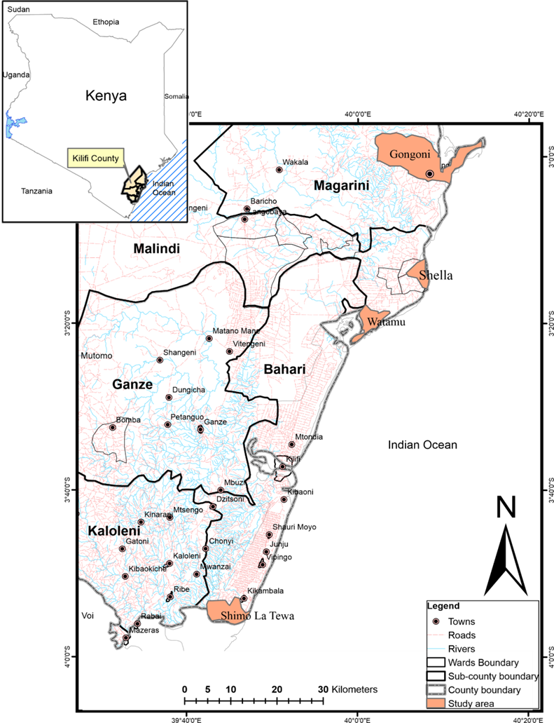
Figure 3.1: Map of the study area, Kilifi County
Source: CGOK (2018)

3.2 Research design
The study used exploratory research design to explore ocean fishery dependency, poverty, and inequality among households in Kilifi County. The research design was selected because the study area was yet to be exploited regarding the subject matter, and it is more flexible.

3.3 Sampling procedure and sample size
The study employed a multi-stage sampling design; in stage one, Kilifi County was purposively selected due to the existence of ocean fishery resource in the region and the higher level of poverty and inequality. In stage two, a purposive sampling method was used to select 4 Sub-Counties (Malindi, Kilifi North, Magarini, and Kilifi South) since they are located along the Indian Ocean. In stage 3, 4 out of the 35 wards from the 4 Sub-Counties (Shella-Malindi, Watamu-Kilifi North, Gongoni-Magarini, and Shimolatewa-Kilifi South) were selected purposively because they offer important ground for artisanal fishing (CGOK, 2018). Finally, in the last stage, simple random sampling was applied in the selection of 384 households spread over the 4 wards (Table 3.1). More importantly, the study focused on those households that were less than or equal to 15km from the coastal line. The reason for this is that ocean fishery resource is likely to form an important source of livelihood mostly for those households who are close to it. Therefore, given the researcher’s experience with the study area, the distance chosen seemed more appropriate.
Determination of the households sample size was based on the Cochran’s formula (1977) as described;
(1)
Households
Where;
$n_{0}$= minimum estimated sample size,
z = value of the t-distribution corresponding to the selected value of alpha 0.5= 1.96,
p = population proportion estimate, and
e = margin of error.
When p is unknown, it is usually put at 0.5 and e at 0.05 (Cochrane 1977).

Table 3.1: Distribution of sample size
Ward | Sub-county | Total household population | Sample size
Shella | Malindi | 9749 | 111
Watamu | Kilifi North | 5180 | 59
Gongoni | Magarini | 5004 | 57
Shimolatewa | Kilifi South | 13699 | 157
Total |  | 33632 | 384

3.4 Data collection and analysis
The primary data was collected from each household through face-face interviews with the household heads since it requires a lower cognitive load on the respondents. In administering the structured questionnaires (appendix I), the researcher sought permission from the National Commission for Science, Technology, and Innovation (NACOSTI) through the graduate school of Egerton University to conduct the study (appendix IV). Also, the questionnaire was administered by trained personnel once the pretesting procedure was affirmed. In this regard, the structured questionnaire was carefully tested to determine the validity of the questionnaire. The data collection process was augmented by observations to capture socioeconomic characteristics, institutional factors, idiosyncratic and covariate shocks, as well as the income and poverty status of the households.
Further, the study used descriptive and econometric modeling to gain clear insights into the ocean dependence activities and livelihood options, and the factors affecting the dependence as well as its implications on poverty and inequality. Data were analyzed using SPSS and STATA computer software.

3.5 Analytical framework
Objective 1: To determine the livelihood options of households in Kilifi County.
The objective was analyzed using descriptive statistics such as percentages, frequency distribution and mean in the form of tables. More importantly, it involved comparing means income from each livelihood options pursued by the household and associated livelihood characteristics.

Objective 2: To determine factors influencing the level of ocean fishery dependence among households in Kilifi County Kenya.
In analyzing this objective, the study measured the ocean fishery dependence by dividing the household income from the ocean fishery resource by the total household income. Thus, the dependent variable was expressed as the proportion of the total household income as described;
(2)
Where: Y* is the ocean fishery dependence ranging between 0 and 1. The numerator (A) represents household income generated from ocean fishery and related activities (fishing, fish trading and processing, boatbuilding, and selling of fish equipment) less associated expenses, while the denominator (B) reflects total household income. Total household income involved a summation of income from crops (value of crop produced less cost of inputs), net fisheries-related income and livestock income (sum of income obtained from selling of live animals less cost incurred in purchasing live animals and inputs), household members’ wages and salary, remittances and business income (Mathenge et al., 2010).
The fractional response model (FRM) was used to analyze the factors influencing ocean fishery dependence. FRM was preferred to linear regression models such as Ordinary Least Square (OLS) because they are not fit to estimate fractional dependent variables and, therefore, may produce estimates outside the unit interval (Chegere, 2018). The non-linear models such as logit and probit transformations may be applicable in this case; however, they do not consider observations that lie at the boundaries and hence may result in a truncation problem. Further, the Tobit model may seem appropriate for bounded dependent variables; however, in proportional data, the values outside the unit interval are not feasible. Therefore, FRM remains the best model for handling proportional dependent variables and overcoming the observed limitations in other econometric models. According to Papke and Wooldridge (1996), the model is a synthesis and an extension of quasi-maximum likelihood (QML) methods and generalized linear models (GLM) as described;
(3)

where;
y_{i} = Dependent variable defined as (0 ≤ y_{i} ≤ 1),
x_{i} = Explanatory variables for household i,
G(.) = Logistic regression function that will be estimated directly using QML based on Bernoulli log-likelihood function as shown;
(4)
Given Bernoulli distribution is a linear, exponential family (LEF), the estimator of QML, θ will be defined as;
(5)
Therefore, θ is normally distributed, and the method can generate consistent estimates of the fractional response variable. The variables in the fraction response model are presented in Table 3.2 from the review of past studies;
Table 3.2: Variables used in the fractional response model
Variable |  | Description | Measurement |  | Expected sign
Dependent variable
FISDep | Ocean Fishery Dependence |  |  | The ratio of household income from ocean fishery resource to Total household income
Independent variables
Age | Age in Years of the household head |  |  | Continuous (Years) |  | +/-
Gen | Gender of the household head |  |  | Dummy=1 if male, 0=female |  | +/-
Educ | Years of education of the household head |  |  | Discrete (Years) |  | -
Asset | Value of agricultural productive assets |  |  | Continuous (monetary in Ksh) |  | +/-
HSize | Number of households members |  |  | Discrete |  | +
Grp | Group membership of the household head |  |  | Dummy=1 if Yes, 0=No |  | +/-
Credit | Whether credit is a constraint |  |  | Dummy=1 if Yes, 0=No |  | -
Land | Security of land tenure |  |  | Dummy=1 if Yes, 0=No |  | -
Land size | Size of the land owned |  |  | Continuous (acres) |  | -
Mark | Walking time in minutes to the market |  |  | Continuous (Minutes) |  | +/-
Dist | Walking distance to the fishery resource |  |  | Continuous (Minutes) |  | -
Rainfall | Rainfall index |  |  | Dummy=1 if best, 0=Otherwise |  | -
Flood | If the household experienced a flood in the last 3 years |  |  | Dummy=1 if Yes, 0=No |  | +
Health | Health shock |  |  | Dummy=1 if household reports illness of member(s), 0=Otherwise |  | +
Price | Price shock |  |  | Dummy=1 if household faces price fall of fish, 0=Otherwise |  | +
Objective 3: To determine the effect of fishery ocean dependence on poverty and inequality on households in Kilifi County.

3.5.1 Measuring poverty
Previous literature has been built on the Forster-Greer-Thorbecke (FGT) poverty index to estimate income poverty (Foster et al., 1984; Mathenge et al., 2010; Ogutu & Qaim, 2018). However, income poverty has several drawbacks that include; using income as the lone indicator of measuring the wellbeing of an individual and hence limited since it does not reflect and incorporate the key dimensions of poverty associated with the quality of life. Also, the income poverty approach does not guarantee that households with income at or above the poverty line would use their incomes to purchase the minimum basic needs. This implies that households may be non-poor in terms of income but deprived of basic needs (Kabubo-Mariara et al., 2011). Income poverty is an indirect approach to assess the ability of the household to satisfy basic needs. Therefore, the study focused on the multidimensional measurement of poverty as developed by Alkire and Foster (2011) in its analysis.
Multidimensional poverty offers an added advantage compared to income poverty since it enables the researcher to assess directly the types of basic needs a household can actually satisfy. Also, the multidimensional poverty approach uses two cutoffs in the identification analysis. The first cutoff is the specific threshold in each dimension for an individual to be considered deprived. The second cutoff is the number of dimensions taken into account for an individual to be regarded as poor. Additionally, the approach allows for decomposability, which is critical for policy targeting. Moreover, the multidimensional poverty approach also allows the researcher to have freedom in assigning different weights to different indicators (Kabubo-Mariara et al., 2011). In this regard, multidimensional poverty indicators for quantitative impact analysis and a weighted procedure for the multidimensional poverty index (MPI) were applied. The approach was preferred to factor and cluster analyses because it provides absolute poverty levels and allows for poverty comparison across different settings (Ogutu & Qaim, 2018).
The MPI measures acute poverty by capturing information on the share of the households that experience multiple deprivations (multidimensional headcount ratio) and their deprivation intensity. Therefore, the study deployed the same approach applied by Alkire and Foster (2011) and Ayuya et al. (2015) who recommended various dimensions of poverty such as living standard, health, education, and assets and several indicators for deprivation assessment as indicated in Table 3.3. The dimensions were derived from human development components such as Millennium Development goal (Ayuya et al., 2015). Further, indicators were weighted equally using nested weight structure (Alkire & Foster, 2011). In this sense, for a house to be defined as multidimensional poor, poverty cut off of 1/3 of the total weighted indicators was used (Ayuya et al., 2015).
Table 3.3: Dimensions and indicators of the multidimensional poverty index
Dimension and indicator | Description and deprivation cutoff
Education
School achievement | Deprived if the household spouses have not completed the primary level of education
School attendance | Deprived if the household has school-aged children not going to school
Standard of living
Electricity | Deprived if the household has no electricity
Drinking water | Deprived if the household does not have access to safe drinking water or they have to walk over 30 min to get safe drinking water
Sanitation | Deprived if the household has no descent pit latrine
Flooring | Deprived if the household house is earth
Assets
Phone | Deprived if the household does not own a mobile phone
Radio and/or television | Deprived if the household does not own at least radio
Vehicle | Deprived if the household does not own at least a bicycle
Health
Nutrition 1 | Deprived if the household reports a household dietary diversity score of 6 and below out of the possible 12 food groups
Nutrition 2 | Deprived if the household relies on relief food or any case of malnutrition in the past 2 years
Access | Deprived if the household has difficulty in meeting basic public hospital bills
Source: Adapted from Ayuya et al. (2015)
The MPI measures for each household were calculated, first by determining the total household deprivation score through the summation of all weighted values, as shown in Table 3.3. The score was ranging between zero and one, with a higher value indicating a higher deprivation level. Second, it involved determining multidimensional poverty dummy, which is assigned one if the total deprivation score of the household is greater than or equal to a common threshold of 0.33 and zero otherwise (Alkire & Santos, 2013). Third, it involved determining multidimensional poverty intensity, which equals the deprivation score if the household is multidimensional poor (MPI dummy=1) and zero otherwise.

3.5.2 Measuring inequality
Inequality was measured using separate inequality measure through a positive multiple of variance. The method was preferred to integrated inequality approaches because it provides intuitive interpretations of the FGT family of poverty measures, including incidence, intensity and, adjusted headcount ratio. Also, separate inequality measure offers a vital framework in studying disparity in multidimensional poverty across subsample of population. In this sense, inequality among the households was captured across deprivation scores obtained through accounting approach (Alkire & Seth, 2014) as described;
(6)
Where l(x) represents inequality among the households, t is the sample size, x_{i} is the individual’s deprivation scores, and µ(x) is the average deprivation score for the sampled households. The formula was applied instead of Ʃ^{t}_{i=1}[x_{i}-µ(x)]²/t-1 since it satisfies population replication invariance, which states that l(x´)=l(x) (Alkire and Seth, 2014).
Multidimensional poverty and materials deprivation have been reported to increase simultaneously with income inequality (Yang & Vizard, 2017). Therefore, the Gini coefficient and Lorenz curve were also estimated to determine the effect of ocean fishery income in a diversified livelihood option for policy recommendations.
(7)
(8)
Where S_{K} represents the share of component k in the total income, G_{k} is source Gini that correspond to income distribution from source k, R_{k} is the correlation of Gini between the distribution of total income and income from source k, F(y) = Cumulative distribution of total income, and F(y_{k}) is the cumulative distribution of income source k.
Equation 7 will allow the study to decompose the effect of a particular income component, for instance, ocean fishery resource, upon total income inequality, as the product of the variables in Table 3.4.
Table 3.4: Variables used in the Gini coefficient
Variable | Description | Measurement | Expected sign
Dependent variable
G | Total Income Inequality | Household income ratio
Independent variables
S_{k} | Source income | Continuous | +
G_{k} | Income source Gini | Continuous | +
R_{k} | Gini correlation with total income | Continuous | -
The study decomposed the total income inequality by income sources to estimate the effect of a marginal change in ocean fishery resource income in total income inequality holding all other income sources constant (Lopez-Feldman et al., 2006).
(9)
Where;
(10)
In this case, assume the change in income source k, ocean fishery in our case, equals e_{k}, and G reflects the Gini coefficient prior to the income change. Therefore, the percentage change in inequality due to the small percentage change in ocean fishery resource income will equal the initial share in total income subtracted from the initial share of the income source in inequality. Also, the study used a bootstrapping technique to test the statistical significance of the inequality measure.

3.5.3 Econometric analysis on the effect of ocean fishery dependence on multi-dimension poverty indices
Determination of the effect of ocean fishery dependence on multidimensional poverty indices can be problematic due to the non-randomness nature of the decision to participate in ocean fishery. The non-randomness of ocean fishery dependence could result in sample selection bias. However, this is usually addressed through matching approaches. In this regard, the treatment group is compared with the non-treatment group that has similar observable characteristics. The approach entails estimation of the propensity score, p(X_{i}), described as the conditional probability of an individual to be included in the treatment group with pre-treatment attributes X_{i} given. Further, propensity score matching is underpinned by the conditional independence assumption (CIA). Through this assumption, the average treatment effect on the treated (ATT) can be estimated as described;
(11)
(12)
Analysis of the treatment effect of ocean fishery dependence using equation 13 is only limited to binary treatment variables. Another approach that could be applied in place of propensity score matching is the endogenous switching regression (ESR). The endogenous switching regression is a popular model in impact assessment due to its strength in accounting for both observable and unobservable factors affecting outcomes and treatment assignments. However, the approach is not applicable to multivalued treatment scenarios. Further, BFG or multinomial endogenous switching regression may seem an appropriate approach in the determination of the household's decision to participate in ocean fishery and analyze its impact on different outcomes of interest. Nevertheless, the approach cannot be used in the estimation of the average treatment effect of moving from one dependency level to another. Based on this background, the study opted for a multivalued treatment effect model as recommended by Cattaneo (2010) in its analysis.

3.5.3.1 Multivalued treatment effect model on the potential outcomes
To specify the effect of ocean fishery dependence on inequality and poverty outcomes, the study followed the same framework presented by (Issahaku & Abdulai, 2020; Linden et al. 2016). In particular, let us consider units denoted as N is withdrawn from a large sample. In this regard, for each household i, (i = 1,…, N), the variables (Yi, Ti, Xi) are observed. Yi represents the vector of outcomes, Ti is a multivalued treatment variable (Relative income on ocean fishery), which takes integer values between 0 and K, while Xi, on the other hand, denotes the vector of the household characteristics. The variable Dit, which defines the indicator of receiving treatment t for household i can be described as;
(13)
Each household, Yi₀,…,Y_{ik}, is associated with the potential outcome. This is described in equation 14, where Y_{it} represents the potential outcome for each household i in which T_{I}=t and t ∈ 𝔗 = (0,…,K). It is worth to note that only one of the potential outcomes will be observed in this case, depending on the dependency level. Following the framework presented by Cattaneo (2010), the observed outcome, Yi, can be expressed in terms of treatment indicator D_{it} and potential outcome Y_{it} as described;
(14)
Let m and l represents different treatment levels (dependence levels), such that for treatment effect δ, of treatment level m versus l can be expressed as the difference between the potential outcomes related with distinct levels;
(15)
Identification of treatment effect using equation 15 will be difficult without considering further assumptions. The reason for this is because of the non-randomness nature of the treatment assignment of the observational data associated with this study. In this regard, the multivalued treatment effect employs two assumptions; overlap assumption and conditional independence assumption (CIA). This will enable the creation of an aspect of randomness. Most importantly, conditional independence assumption (CIA) signifies that once observable pre-treatment characteristics (Xi) is controlled, the choice of ocean fishery dependence will be more of a random assignment and hence uncorrelated with the potential outcomes, which in this case are multi-dimension poverty indices as described;
(16)
Given the covariates X_{i}, treatment D_{it}, and potential outcome Y_{it} are independent. Conditional independence assumption (CIA) is regarded as the strongest assumption in impact evaluation literature. The reason for this is that the assumption takes into account the unobservable confounders that simultaneously affect ocean fishery dependence and the potential welfare outcomes derived. This implies that violation of the conditional independence assumption will result in biased estimation of the effect of ocean fishery dependence on poverty and inequality. However, in the presence of sufficient data and adequately good covariates of the treatment D_{it}, one can obtain valid estimates (Issahaku & Abdulai, 2020) of average treatment effects of ocean fishery dependence on welfare outcomes.
Further, the overlap assumption is defined as; 0 < Pr[Ti = tXi = x], Ɐt ∈ Λ. The assumption ensures that each covariates X_{i} is associated with a positive probability of the households with similar characteristics to be selected in a particular treatment level. Conditional independence assumption and overlap assumption are jointly denoted as the ignorability assumption (Cattaneo, 2010). Another assumption is the stable unit treatment value assumption (SUTVA), which is also concerned with the identification of average treatment effects; however, it cannot be verified from the data. Taking into account the three assumptions, one will be able to employ propensity score regression adjustment or other more robust models to estimate conditional mean function at different treatment levels. More so, observing the three assumptions will make it possible to obtain treatment effects through parametric regressions (Cattaneo, 2010).
The generalized propensity score (GPS) is preferred in this case compared to directly conditioning on Xi since it is a more practical alternative in a multivalued treatment state. In particular, the generalized propensity score entails the conditional probability of a household belonging to a specific treatment level (dependency level) given the pre-treatment covariates X_{i} as described;
(17)
Given the characteristics of the treatment, the GPS, which is defined as rˆ (t, Xi), can be estimated using the multinomial logit model. In this regard, it can be used to weigh observations and hence estimate average treatment effect (ATE) and potential outcome means (POM) for ocean fishery dependency levels among households with T_{i}= t in the selected sample. For instance, application of efficiency influence function estimator, potential outcome means can be estimated as;
(18)
(19)
From the equation rˆ (t, Xi) represents the estimated generalized propensity score and m, l = t, Ɐ t ∈ Λ, N. is the total number of households belonging to a particular treatment level, with T_{i}=l and T_{i}=m, l ∈ Λ = (1, 2, 3). In this study, Λ =1 refers to non-ocean fishery dependence, Λ =2 refers to low ocean fishery dependence and Λ =3 refers to high ocean fishery dependence. Moreover, Yˆ (t) denotes estimated conditional mean functions relating to each treatment level.
Further, the quantile multivalued treatment effect was also estimated to determine the heterogeneity in ocean fishery dependence at 0.25, 0.50, and 0.75 quantiles of the distribution of potential welfare outcomes. In the estimation of both quantile treatment effect (QTE) and average treatment effect (ATE), an efficiency influence estimator (EIE) was used. The reason for this is that the efficiency influence estimator is doubly robust compared to estimators of regression adjustment (RA) and inverse probability-weighted treatment (IPW) (Cattaneo et al., 2013; Linden et al., 2016).
(20)
Finally, in the implementation of the multivalued treatment effect approach, the generalized propensity score was estimated using multinomial logistic regression using the three dependence level variable as the outcome as described in equation 20, r^( x, t) denotes the estimated generalized propensity score. The variables (X_{i}) on the right-hand side were estimated using the bfit command present in Stata. Most importantly, the study estimated potential outcomes for each dependence level. Pairwise contrasts were also estimated between all dependence levels to find the significance of moving from one dependence level to another.
The level of ocean fishery dependence is hypothetically endogenous, and therefore, could lead to a biased estimate as a result of its correlation with the error term. That is why the study controlled for covariates X_{i}, including distance to the ocean fishery market and distance to the ocean fishery resource. The rationale for the inclusion of the variables is that a shorter distance to the fishery market reduces transaction costs and better market access, which could increase ocean fishery dependence. Further, the reduction of distance from the ocean fishery resource could also increase ocean fishery dependence due to increased expected net economic value, which ultimately encourages the decision to participate.

3.5.3.2 Dose-response functions (DRF)
The generalized propensity score (GPS) was deployed to capture the impact of ocean fishery dependence on household welfare in a continuous treatment assignment instead of the discrete analyses (Hirano & Imbens, 2004). The analysis was taken on the households who participated in the ocean fishery and related activities. The interest of the study was to estimate the average dose-response function, which entails the potential welfare outcome Y_{i} (t) of household i to specific ocean fishery dependence level t as described.
(21)
Where θ is the DRF and t represents the treatment level measured as the share of ocean fishery income on the total household income. Further, the study presumed the weak un-confoundedness under the assumption that average DRF can be estimated by GPS to eliminate the selection bias (Hirano & Imbens, 2004). The assumption of un-confoundedness is usually strong but untestable. However, its plausibility is dependent on the richness of literature, particularly on the covariates determining the selection into the treatment (Bia & Mattei, 2008; Hirano & Imbens, 2004).
After GPS (Rˆ_{i}) estimation, the conditional expectations of specific outcome variables were modeled using two scalar variables the GPS (Rˆ_{i}): θ (t, r) = E [Y_{i}|T_{i} = t, Rˆ_{I} = r] and the treatment (T_{i}). This was achieved using quadratic approximation (Bia & Mattei, 2012).
(22)
The dose-response function at each treatment level t was finally estimated and averaged over the general propensity score as shown by Eq. 23. Also, confidence bounds at 95% were estimated using bootstrapping approach (Hirano & Imbens, 2004).
(23)
Prior to running the model, an endogeneity test was performed on ocean fishery dependence on poverty and inequality using Durbin–Wu–Hausman test (Cameron & Trivedi, 2005).

3.6 Ethical consideration
Ethical measures are principles that the researcher binds himself to conduct the research during and after data collection. The Initial ethical approval of this research study was secured from Egerton University. A research permit was obtained from the National Commission for Science, Technology, and Innovation (NACOSTI). The respondents were assured that the information given was for the purpose of the research and will be treated with the utmost confidentiality.

CHAPTER FOUR

RESULTS AND DISCUSSION
This chapter presents the results and discussion on the evaluation of ocean fishery dependence on poverty and inequality. In the first section, descriptive statistic result was provided for the first objective to identify the livelihood options. The second section presents the results for the second objective in which factors influencing the ocean fishery dependence were determined using a fractional response model. Lastly, in the third section, multidimensional poverty indices were initially estimated. Then the multivalued treatment effects model was used to determine the effect of ocean fishery dependence on poverty and inequality.

4.1 Determination of livelihood options among households
The identified livelihood options involve ocean fishery and related activities, agriculture, wage employment, self-employment, and other livelihood option (remittances and selling of assets). Ocean fishery and related activities included households participating in fishing, boat building, fish trading and processing, and selling fishery tools and equipment. Agriculture included households involved in farming and livestock production. Self-employment represented households who are self-employed in various businesses and enterprises. Wage employment defined those households in paid jobs. Remittances and selling of assets included households who received earnings from gifts, transfer of money, and sales of assets. As presented in Table 4.1, of the total number of households, approximately 68% participated in the ocean fishery and related activities, 36% pursued agriculture, and 31% participated in self-employment. Further, about 25% of the households participated in wage employment, while those households with income from remittances and selling of assets were about 9%.
Table 4.1: Livelihood options among households in Kilifi County
Livelihood options | % of households participating | % of households not participating | Income by source (Ksh)
Fishery and related activities | 67.7083 | 32.2917 | 82411.25
Agriculture | 36.1979 | 64.8021 | 4131.79
Self-employment | 31.9896 | 69.0104 | 11640.90
Wage employment | 25.2604 | 75.7396 | 30910.00
Others (Remittances and selling of assets) | 9.8542 | 91.1458 | 2046.78
Moreover, ocean fishery and related activities were divided into four groups, including fishing, fish trading and processing, boat-building, and selling of fish equipment. Fishing had the highest number of players at 191 of the households, while a few actors only dominated boat building at only 5 of the households. From Table 4.2, it is clear that men dominated all ocean fishery livelihoods except fish trading and processing. Women were active in fish trading and processing at about 63% because small-scale processing requires low capital and can be undertaken by comparatively unskilled labour. Overall, the largest source of income comes from fishery and related activities, with a lion share of about 68% of the total households. This implies that the households in the sample are fishery-dependent since they relied on the activity for their economic, cultural and social success.
Table 4.2: Percentage of ocean fishery and related activities by gender
Gender | Fishing (n=191) | Fish trading and processing (n=81) | Boatbuilding (n=5) | Selling of fish equipment (n=7)
Male | 97.90% | 37.04% | 100.00% | 100.00%
Female | 2.10% | 62.96% | 0.00% | 0.00%
Total | 100.00% | 100.00% | 100.00% | 100.00%
The basic characteristics of the households in Kilifi County are presented in Table 4.3. The share of dependents and non-dependents in the ocean fishery is approximately 68% and 32%, respectively. The dependents denote those households that depend on ocean fishery for their livelihood. In Table 4.3, the households are grouped into those that receive income from the ocean fishery and related activities and those that do not. Data revealed a lower level of education for the household heads that participate in ocean fishery at a mean of about 7.9 compared to 12.5 for those that do not participate. Majority of the households that are close to the ocean fishery resource tend not to value education and usually drop out of school. Ocean fishery serves as an immediate and direct source of income (Ndhlovu et al. 2017; Nguyen et al. 2018), which reduces the individual's incentive to pursue further education for future employment.
On average, the participating group also had lower age of about 41.2 years compared to 44.0 years of the non-participating group. Households with younger household heads tend to engage more in ocean fishery and related activities. This could further be explained by the less desire of the younger households to increase their education level and, as such, attracted to ocean fishery through monetary influence. Further, investors in the coastal region hire fishing equipment to fishers. This attracts more young individuals to ocean fishery due to their ability to use advanced fishing gears that are readily available and could maximize fishing returns.
Households who participate in the ocean fishery and related activities have a lower land endowment and security of land tenure. This implies that households with relatively small landholding have the need and capacity to engage in the ocean fishery. The reason for this is that ownership of bigger lands provides alternative livelihood strategies such as modernized agriculture and private investments. However, in Shella, the size of the landholding was larger for the participating group that had an average size of approximately 5.9 acres compared to 0.7 acres for the non-participating group. This is because households in this region were well off and were combining ocean fishery with other activities such as agriculture to supplement their insufficient income. Additionally, participating households in ocean fishery and related activities have few agricultural productive assets averaging KES 10417.2 compared to non-participating households, KES 71321.3. Asset poverty usually compels individuals to diversify into common pool resources (Nguyen et al., 2020), and as such, they pursue the livelihood option as a safety net in response to idiosyncratic and climatic shocks.
Table 4.3: General differences between dependent and non-dependent households in Kilifi County
 | Households that participate in ocean fishery and related activities |  | Households that do not participate in ocean fishery and related activities |  | Difference in means
Variable | Mean (µ₁) | SD | Mean (µ₀) | SD | (µ₁- µ₀)
Age (years) | 41.2069 | 12.5971 | 44.0244 | 12.8538 | -2.8175
Gender (%) | 0.7969 | 0.4031 | 0.8049 | 0.3979 | 0.0080
Education level (years of schooling | 7.8620 | 2.2828 | 12.4552 | 4.9708 | -4.5932***
Household size (number) | 6.1533 | 2.7996 | 5.8780 | 3.0824 | 0.2753
Credit access (%) | 0.3295 | 0.4709 | 0.8130 | 0.3915 | -0.4835***
Security of tenure (%) | 0.3602 | 0.4810 | 0.5772 | 0.4960 | -0.2170
Land size (Acres) | 0.7527 | 3.2339 | 1.2297 | 2.1270 | -0.6685
Agricultural assets (KES) | 10417.2410 | 42299.6200 | 71321.3820 | 158167.4000 | -60904.9680*
Group membership | 0.8697 | 0.3372 | 0.0407 | 0.1983 | 0.8290***
Distance to the ocean | 3.2811 | 3.3087 | 7.0267 | 4.5196 | -3.7456***
Distance to the fishery market | 2.3088 | 2.9035 | 6.8037 | 4.4596 | -4.4949***
Rainfall | 0.1900 | 0 .2275 | 0.1553 | 0.1216 | 0.0347*
Flood | 0.3487 | 0.6658 | 0.0407 | 0.1983 | 0.3080***
Health | 0.8544 | 0.3534 | 0.8862 | 0.3189 | -0.0318
Price | 0.9425 | 0.2332 | 0.1220 | 0.3286 | 0.8205***
Note: *significant at 10%, **significant at 5%, ***significant at 1%
Another trend was that participating households in ocean fishery and related activities had a shorter distance to the ocean fishery resource. Longer distance to ocean fishery increases the cost of ocean fishery and related activities. An increase in the distance lowers the expected net economic value, which ultimately discourages the decision to participate (Kyando et al., 2019). Moreover, group membership was higher among the participating households compared to those that do not pursue the livelihood option at about 86% and 4%, respectively. Participation in social institutions affects the decision to participate in the fishery resource and hence economic benefit extracted from the commons. Group membership facilitates awareness of the potential gains from ocean fishery (Al-Jabri et al., 2013). Institutions provide relevant information on policy changes, market functions, climatic change, and access to permits that helps the participating group to acquire higher adaptive capacity.
Households that participated in ocean fishery and related activities had a higher level of shocks related to price, floods, and rainfall. Price uncertainty and the fluctuation nature of the ocean fishery returns due to seasons and climatic conditions expose these households to financial and weather shocks. In response to these shocks, households usually participate more in the ocean fishery and related activities to compensate for the lost income. Efforts have been put to organize the ocean fishery under beach management units (BMU) with the primary objective of achieving capacity building and reduce sensitivity to shocks through information sharing and provision of marketing facilities. However, the majority of the actors in the fishery sector lack shocks resilience, mainly attributed to the lack of land ownership. Historical injustices of land have contributed to landlessness in the coastal region (Githunguri, 2017; Klopp & Lumumba, 2017). Furthermore, participating households have lower access to credit. This indicates weak financial development in the region, which in turn makes households vulnerable to shocks.

4.1.1 Ocean fishery dependence among households in Kilifi County
The section presents a discussion on ocean fishery dependence using an income-based approach. The share of the total household's income from the ocean fishery and related activities was determined, as indicated in Table 4.4. Due to the reason that livelihood options are context-specific, the dependency rate was organized into wards. This enabled the researcher to draw a cross-sectional comparison of the level of ocean fishery dependence across the sampled wards. Table 4.4 presents income shares by source for the households under study. Diversification is a critical approach to ensure a consistent flow of income; however, most households who participated in ocean fishery and related activities find it difficult to find the next best diversification livelihood option. This is clearly indicated by a higher dependence on ocean fishery compared to other livelihood options. This could have been attributed to the lack of security of land tenure and lower education levels among the fishing communities, which prevent them from securing formal employment opportunities.
Table 4.4: Income share from different livelihood options by means
Wards | Ocean fishery | Agriculture | Wage employment | Self-employment | Others
Shella | 0.5420 | 0.0281 | 0.2448 | 0.1717 | 0.0116
Watamu | 0.6801 | 0.0130 | 0.1709 | 0.1216 | 0.0071
Gongoni | 0.6413 | 0.0858 | 0.1599 | 0.1018 | 0.0037
Shimolatewa | 0.6771 | 0.0110 | 0.2004 | 0.0996 | 0.0084
The willingness to pursue additional livelihood options among the households was low. Cultural preference and the time-consuming nature of the fishing activities hampered the households to practice diversified strategies. Most importantly, the dependency on ocean fishery extends beyond personal income and employment. The conducted interviews suggest that there is a working culture in this particular livelihood strategy defined by reciprocity and interpersonal relationships, where individuals engage in ocean fishery through social ties and form a significant part of their identity. Additionally, most of the households that were dependent on the ocean fishery were Bajuns and were culturally bounded by self-employment. They felt that ocean fishery provided a sufficient form of self-employment and did not like wage employment due to too much control from employers. These elements offered a critical pathway in the survival and growth of the fishing industry in the coastal region (Carter & Garaway, 2014). With the government at the heart of transforming the sector and organizing beach management units (BMUs), reciprocal interdependencies have become more evident.
Households have been involved in specialized and contract fishing, where fishers enter into informal agreements with the investors. The investors in the ocean fishery have invested in high capital intensive fishing gear. Individual fishers were given the equipment based on the informal agreement that revolved around the fishing proceeds. Fishers were using more advanced gears such as ring nets and hence have been able to receive a considerable catch. However, the owners reaped the most significant shares. For them, ocean fishery was a form of diversification strategy and a means to increase wealth. In this sense, their dependency was low compared to the fishermen. However, they extracted more due to their asset endowment (Langat et al., 2016; Nguyen et al., 2018).

4.2 Factors influencing the level of ocean fishery dependence
The section presents econometric results on the factors influencing the level of ocean fishery dependence using a fractional response model. Preliminary diagnostics were initially determined before proceeding with the analysis to identify statistical problems of heteroskedasticity and multicollinearity. All proposed explanatory variables were subjected to this test to ensure the efficient estimation of model parameters.

4.2.1 Diagnostic test of the variables used in the econometric analysis
This section presents the diagnostic test for the variables used in the econometric analysis to determine multicollinearity and heteroskedasticity. Multicollinearity relates to the condition in which the proposed explanatory variables have high inter-correlations. In the presence of high multicollinearity, it can result in wrong inferential estimates and conclusions because of overinflating standard error, which could make some covariates statistically insignificant that should have been otherwise significant (Daoud, 2017). In this regard, the variance inflation factor (VIF) was used for all continuous independent variables, as shown in Table 4.5. The results indicated that there was no serious linear relationship among the tested independent continuous variables since VIF values were less than 10 (Salmerón et al., 2016; Thompson et al., 2017).
Table 4.5: VIF test results for continuous variables
Variable | VIF | 1/VIF
Age | 1.35 | 0.7416
Household size | 1.43 | 0.7016
Agricultural productive assets | 1.27 | 0.7886
Land size | 1.02 | 0.9775
Distance to the fishery market | 2.80 | 0.3575
Distance to the ocean | 2.86 | 0.3502
Rainfall | 1.06 | 0.9437
Mean VIF | 1.68
Further, contingency coefficients were also calculated for categorical variables to determine multicollinearity, as shown in Table 4.6. The results had coefficients of less than 0.7, and hence there was no strong relationship among these variables (Shin & McCann, 2018). Based on the diagnostic test conducted, there was no strong association among the explanatory variables used in this study.

Table 4.6: Contingency coefficient test for categorical variables
 | Gender | Educ | SocNet | Credit | Land Tenure | Flood | Health | Price
Gender | 1.0000
Educ | 0.0629 | 1.0000
SocNet | 0.1399 | -0.4388 | 1.0000
Credit | -0.0092 | 0.4485 | -0.1580 | 1.0000
Security of tenure | 0.0274 | 0.1264 | -0.1110 | 0.1271 | 1.0000
Flood | 0.0479 | -0.1535 | 0.1752 | -0.1850 | -0.0843 | 1.0000
Health | -0.0461 | -0.0127 | -0.0246 | 0.0181 | 0.2052 | -0.0264 | 1.0000
Price | 0.0326 | -0.4190 | 0.6541 | -0.3844 | -0.1370 | 0.2296 | -0.0432 | 1.0000
All hypothesized explanatory variables were later tested for heteroskedasticity using the White test, as presented in Table 4.7. The method was preferred to the Breusch-Pagan test because, in the nonlinear form of heteroskedasticity, it accounts for both the magnitude and the direction of change (Farbmacher & Kögel, 2017). The result indicated that heteroskedasticity was not a problem, as indicated by a p-value of more than 10%.
Table 4.7: Test for heteroskedasticity
Source | Chi² | Df | p
Heteroskedasticity | 114.41 | 129 | 0.8168
Skewness | 22.22 | 15 | 0.1021
Kurtosis | 8.48 | 1 | 0.0036
Total | 145.11 | 145 | 0.4818
Chi² (129) = 114.41
Prob > chi2 = 0.8168

4.2.2 Fractional response model results on factors influencing ocean fishery dependence
Factors determining the level of ocean fishery dependence were determined using a fractional response model. The results are presented in Table 4.8. The Akaike information criterion (AIC) and Bayesian information criterion (BIC) were 208 and 271, respectively. The likelihood ratio test of the model had a p-value of less than 0.001, indicating a better fit (Shin & McCann, 2018). Pseudo R² of 65% was also higher compared to the set statistical threshold of 20%, and hence ocean fishery dependence is well explained by the proposed covariates (Power et al., 2015). The result in Table 4.8 indicates that several factors significantly influenced the level of ocean fishery dependence among households. They include education level, group membership, credit, security of security of tenure, flood, fish price, and value of agricultural productive assets.
Table 4.8: Fractional response model results on factors influencing ocean fishery dependence
Variable | Coefficients | Robust standard errors | p>Z
Socio-economic factors
Age | -0.0106 | 0.0125 | 0.3990
Gender | -0.5500 | 0.4062 | 0.1760
Education level | -0.8539*** | 0.2536 | 0.0010
Household size | -0.0264 | 0.0486 | 0.5860
Log Agric. productive assets | 0.0402** | 0.0191 | 0.0360
Institutional factors
Group membership | 2.5241*** | 0.3364 | 0.0000
Access to credit | -0.8721** | 0.3202 | 0.0060
Security of land tenure | -0.5424* | 0.3199 | 0.0900
Land size | 0.0129 | 0.0168 | 0.4430
Distance to the fishery market | -0.0551 | 0.0450 | 0.2210
Distance to the ocean resource | -0.0329 | 0.0506 | 0.5150
Covariate and idiosyncratic shocks
Rainfall shock | 0.4722 | 0.6602 | 0.4740
Flood shock | 0.8028* | 0.4350 | 0.0650
Health shock | 0.6650 | 0.4080 | 0.1030
Price shock | 3.0132*** | 0.3220 | 0.0000
Constant | 0.5877 | 0.9777 | 0.5480
Goodness of fit
Number of observation | 384.0000
Log pseudo-likelihood | 0.6520
Wald chi2(15) | 206.6500
Prob > chi2 | 0.0000
AIC | 208.4608
BIC (df=16) | 271.6711
Note: *significant at 10%, **significant at 5%, ***significant at 1%
The education level of the household head was negatively associated with ocean fishery dependence at 1% significant level. Lower education level limits opportunity in formal employment, and fishing provides a livelihood option as it does not require higher levels of education. This finding is consistent with previous studies (Garekae et al., 2017; Nguyen et al., 2018, Nguyen et al., 2020; Selig et al., 2019), where education had a negative effect on both relative and absolute environmental income attributed to higher education opening up alternative employment opportunities in public and private sector jobs. Moreover, education also enhances income diversification and labour diversity (Do et al. 2019; Jin et al., 2018) since it enriches access to information and skills and hence off fishery-related employment opportunities.
The amount of agricultural productive assets had a positive and significant effect on the ocean fishery dependence at 5% significant level. The results have been attributed to the majority of the households diversifying into agricultural production. However, agriculture was pursued in this region, mainly for subsistence with pockets of commercialized agricultural production. This served as a coping strategy against the perceived risk and a livelihood diversification approach in sustaining consumption. The finding is consistent with prior evidence (Ndhlovu et al., 2017; Nguyen et al., 2018), where a positive relationship between asset values and natural resource dependence implies an attempt by the households to build adaptive capacity. This is because the fishery is associated with a variety of disruptions, which could result in fluctuations in the income derived. Therefore, increased asset value is critical as a coping strategy and in sustaining the consumption of the dependent households.
Group membership in agricultural-related activities positively and significantly influenced the level of ocean fishery dependence at 1% significant level. Beach management units (BMU) are the main groups in the region related to agriculture, and therefore, positively influenced ocean fishery dependence. The reason for this is that beach management units are directly related to ocean fishery, and its membership is critical in providing information, skills, knowledge, fishing gears, and market resources that enable fishers to be more efficient. Additionally, membership to beach management units enhanced repeated social cohesion and peer influence, influencing members’ behaviour to participate in common economic activity (Alexander et al., 2018).
Access to credit negatively and significantly influenced ocean fishery dependence at 5% significant level. Credit access increases financial resources, reduces cash constraint, and enhances participation in off-fishery investment opportunities, which will reduce dependence on ocean fishery. The results are in line with the work of Kimengsi et al. (2019), who found that lack of access to credit increases dependence on natural resources. The reason for this is that access to credit prompts households to pursue more lucrative livelihood strategies that are not labour intensive. Similarly, Kleih et al. (2019) reported that small-scale and medium actors in the fishery sector in Egypt have poor access to credit due to the information gap and lack of suitable collateral.
Security tenure of land negatively and significantly influenced the level of ocean fishery dependence at 10% significant level. Ceteris paribus, security of tenure decreases ocean fishery dependence by the probability of 0.5424%. Land ownership right prompts households to invest in agriculture and off-fishery employment opportunities. Security of tenure provides the right to usage, which encourages individuals to engage in entrepreneurial livelihood strategies outside the ocean fishery, such as business investment and intensive agricultural production. Another possible explanation relates to the land and squatter issue facing the coastal community. The problem was contributed by the colonial era, non-recognition of the land tenure security system, and hence dispossession of indigenous people by successive regimes. Despite the enactment of the constitution 2010 squatter problem continues to persist due to a lack of independent enforcement mechanisms and political goodwill (Githunguri, 2017; Klopp & Lumumba, 2017). The destabilizing political effect in land reforms in the coastal region of Kenya has increased land inequality among households. As a result, local individuals are exposed to land-related violence, social division, and impeded economic growth, which has enhanced dependence on natural livelihood options. The result is consistent with the work of Teshager et al. (2019), who established that dependence on one particular livelihood option and lack of diversification are significantly influenced by insecure land ownership rights.
Ocean fishery dependence was further influenced by shocks-related to floods at 10% significant level. The results indicated that households that experienced floods have a higher likelihood of depending on ocean fishery and related activities. This is particularly true in Malindi during the rainy season when the river Sabaki moves into the Indian Ocean. Mixing of waterfronts of different densities raises the sea level and result in high and strong tides disrupting fishing activities. Similar findings were found by Nguyen et al. (2018), who founded that households that are dependent on natural resources have a significantly higher number of shocks, such as floods. Ndhlovu et al. (2017) argued that the small-scale sector is vulnerable to climate change and through flooding events and fluctuating water levels.
Further, Price shock had a positive and significant effect on ocean fishery dependence at 1% significant level. The reason for this is due to the seasonal nature of the livelihood option. Ocean fishery catches depend on seasons, with the kusi season, which occurs from April to July being the poorest. During this period, rough seas and heavy rainfall hamper the supply of fish and subsequently resulting in a higher price. On the contrary, kaskaz season, which occurs from August to March, is suitable for fishing activities since the ocean is relatively calm. However, due to the higher supply of fish, price decreases, ultimately reducing both absolute and relative income from ocean fishery and related activities. The findings indicated how the vicious cycle between weather shocks and price uncertainty results in natural resource dependence. Given credit constraints, most households in the region used risk-sharing strategies such as advance payment to cope with flood events and price fluctuation in the fishing industry.

4.3 Effect of ocean fishery dependence on poverty and inequality
This section presents the results on the effect of ocean fishery dependence on poverty and inequality. Ocean fishery dependence, which is the treatment variable in this analysis, was measured by the income derived from the ocean fishery divided by the total household income. This was critical to capture ocean fishery as a continuous variable with the assumption that higher income from the livelihood option indicates increased ocean fishery dependence. For the purpose of this study, households who do not have income from the ocean fishery were classified as non-dependency. Low dependency referred to households with an ocean fishery dependence rate of more than 0% and less than 30%. High dependency involved households with an ocean fishery dependency rate of more than 30% (Lepcha et al., 2019). Descriptive statistics were carried out for the multidimensional poverty indices on the three subgroups, as indicated in Table 4.9.
Table 4.9: Descriptive statistics of multidimensional poverty indices
Outcome variables | Non-dependence | Low dependence | High dependence | F-statistics
Household poverty score | 0.2507 | 0.2933 | 0.3442 | 10.3000***
Multi-dimension poverty intensity | 0.1412 | 0.1953 | 0.2386 | 5.8500**
Multi-dimension poverty dummy | 0.2901 | 0.4262 | 0.4792 | 5.9700**
Note: **significant at 5%, ***significant at 1%
From Table 4.9, the result indicated that in terms of multidimensional poverty, the most dependent households are more affected by the depth and prevalence of the household poverty score, multidimensional poverty intensity, and multidimensional poverty dummy at about 0.3, 0.2, and 0.4, respectively. This could have been attributed to low diversification to alternative livelihood options by most households participating in ocean fishery resulting in low adaptive capacity and more sensitivity to weather and idiosyncratic shocks. Also, higher incidence among the dependent households could be as a result of poor financial management and lack of sustainable land ownership rights, which contribute to low entrepreneurial activities and minimum efforts in accumulating wealth.
The increase in poverty with an increase in natural resource dependence is in line with previous studies (Jin et al., 2018; Nguyen et al., 2018; Nguyen et al., 2020). They reported that although dependence on natural resources could alleviate poverty, higher dependence is likely to perpetuate poverty. The reason for this is that higher dependence on one livelihood option that is associated with a wide range of stressors exposes households to dynamic vulnerability and hence poverty. Within this context, the natural resource is used to provide safety nets in response to shocks and gap filling of seasonal shortfalls. Using natural resource as a risk management strategy among households could lower their capacity to escape poverty. This is demonstrated by increasing multi-dimension poverty indices across the three subgroups. Another possible explanation for this could be that the root cause of poverty in the fishery is not the low productivity but an acute institutionalization, economic, and political marginalization of the fishing communities (Béné et al., 2016).
As trawlers and mining companies invade the ocean resource, degradation is more than likely to happen. This could hamper natural resource livelihood resilience and result in a social-ecological trap or ecosystem service curse (Li & Zander, 2019). This will be further escalated given the fact that the region is affected by historical injustices on land allocation and insufficient credit market and social insurance. Thus amid severe shocks, households cut back their expenditure on nutrition, education, and assets. This not only enhances poverty in the short run but also potentially does so in the long run. Globally, captures from ocean fishery play a critical role in economic development, food provision as well as a range of cultural and social benefits to the local population (Béné et al., 2016). Majority of the local population in these areas do not pursue a livelihood diversification strategy; hence could easily be stuck in a poverty-environment trap. The outcome of this is natural resource degradation and intense marine conflicts, particularly in protected areas.

4.3.1 Inequality measure on the ocean fishery dependency
Table 4.10 presents results of inequality across ocean fishery dependence levels using the separate inequality measure and positive-multiple variance. The findings indicated an increasing level of poverty and inequality with dependence levels. More specifically, non-dependence, low dependence, and high dependence levels had inequalities of approximately 0.12, 0.13, and 0.14, respectively. This suggests that higher dependence on ocean fishery and related activities has an un-equalizing effect on attaining different dimensions of human life. This could have been attributed to higher returns gained by specific households who have invested in specialist fishing. The returns accrued to these households enabled investment in various dimensions such as education, assets, health insurance, housing, and better living conditions resulting in lower deprivation scores. This could also be explained by urbanization, social network, and tourism that have exposed some dependent households to better market opportunities, such as the supply of prawns and crabs in reputable hotels. Further, ocean fishery is an open resource; however, territorial control and privatization of productive areas have created a disparity in economic benefits gained by different households (Neiland & Béné, 2013).

Table 4.10: Inequality across dependency levels
Dependence levels | Incidence (H) | MPI (M₀) | Intensity (A) | Inequality
Non-dependency | 29.01% | 0.1570 | 54.12% | 0.1245
Low dependency | 42.62% | 0.1850 | 43.41% | 0.1266
High dependency | 47.92% | 0.2470 | 51.54% | 0.1413
Note: Adjusted multidimensional headcount M₀=H×A, and Intensity (A) is the deprivation score among the poor (Alkire and Suman, 2014).
Nhem et al. (2018) reported that higher inequality among natural resource-dependent households is due to weak natural resource management that results in loss of biomass. This affects the livelihood of the poor, who are constrained by a lack of alternative livelihood strategies resulting in less capability and incentive to pursue other dimensions of human life. Further, fishing communities are typically considered poor (Béné & Friend, 2011; Jeyanthi et al., 2016; KC et al., 2019; Nabi et al., 2011; Stanford et al., 2013) because of socio-institutional constraints that spur vulnerability to climatic shocks. Therefore, higher inequality among ocean fishery-dependent households could have been attributed to the positive relationship between MPI and inequality, which has been reported to be higher among the poor (Alkire & Suman, 2014; Espinoza-Delgado & Klasen, 2018). Given that multidimensional poverty and material deprivation has a positive and significant relationship with income inequality (Yang & Vizard, 2017); the study also examined Gini decomposition by income sources to determine the effect of ocean fishery income in a diversified livelihood option effective for policy recommendations as shown in Table 4.11.
Table 4.11: Gini decomposition by income source
Income source | Share in total income (S_{K}) | Income source Gini (G_{K}) | Gini correlation (R_{K}) | Share in total income inequality | Percentage change in Gini arising from a 10% increase in income source
Ocean fishery and related activities | 0.7605 | 0.6194 | 0.8752 | 0.8757 | 0.1152 ( 0.0375, 0.1823)
Agriculture | 0.0159 | 0.9652 | 0.1911 | 0.0062 | -0.0096 (-0.0184, 0.0036)
Wage employment | 0.1101 | 0.8543 | 0.0813 | 0.0162 | -0.0938 (-0.1093, -0.0683)
Self-employment | 0.0504 | 0.8320 | -0.0650 | -0.0058 | -0.0562 (-0.0703, -0.0441)
Other income (Remittances and selling of assets) | 0.0024 | 0.9677 | -0.4203 | -0.0021 | -0.0046 (-0.0077, -0.0026)
Total household income |  | 0.4708
Note: 95% bootstrapped percentile confidence intervals are presented in parenthesis as proposed by López-Feldman (2006) in Gini decomposition analysis.
The results in Table 4.11 indicated that ocean fishery and related activities had the largest share of inequality, which was 0.8752. As such, ceteris paribus, a 10% increase in income from ocean fishery, increases Gini coefficients of total income inequality by 0.1152% and is statistically significant from zero. However, the aggregate income Gini is 0.4708, which is lower compared to the source income Gini coefficients. This implies that diversification of income reduces income inequality among households. Nevertheless, other livelihood options have an equalizing effect on the distribution of income, as indicated by negative percentage changes in Gini coefficients.
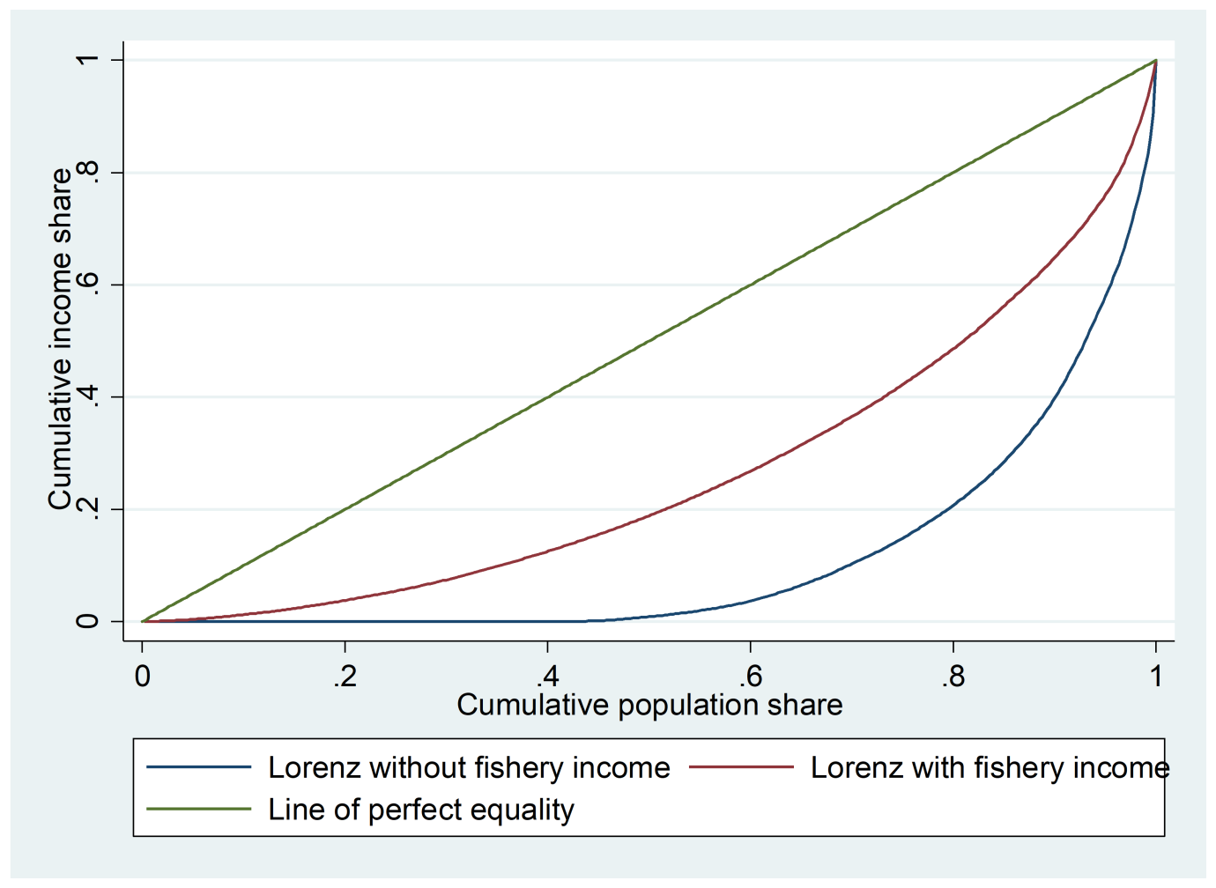
Figure 4.1: Lorenz curves for household income with and without ocean fishery income
Figure 4.1 presents the results of the Lorenz curve on the impact of income from ocean fishery on income inequality. As indicated in the diagram Lorenz curve was constructed using data of total household income with and without ocean fishery income. The results indicated that the addition of ocean fishery income to household income reduces income inequality. On the contrary, the removal of ocean fishery income from the total household income increases income inequality. This implies the significant role played by the natural resources in the reduction of income inequality in a diversified livelihood strategy (Nguyen et al., 2018)

4.3.2 Econometric analysis on the effect of ocean fishery dependence on poverty and inequality
A diagnostic test on the existence of endogeneity was determined using Durbin–Wu–Hausman test, as indicated in Table AIIa. The result indicated the existence of endogeneity in a multidimensional poverty dummy at a 10% significant level. Sargan’s test was also used to test whether the instruments are correlated with the error terms (Sargan, 1958); the result was Pr > x²(1) = 0.281, for household poverty score, Pr > x²(1) = 0.448 for multidimensional poverty intensity and Pr > x²(1) = 0.659 for multidimensional poverty dummy. This indicates that the error terms were uncorrelated with the instruments due to larger and insignificant p-values. Further, the study used the Wald test to determine the joint significance of the instrumental variables and in testing the hypothesis of weak instruments. The Wald test was x²(2) = 65.04 at a 1% significant level as presented in Table AIIb; therefore, the hypothesis of weak instruments was rejected.
To determine the effect of ocean fishery dependence on poverty and inequality, the multivalued treatment effect model was determined. Firstly, multinomial logit was estimated to predict the probability of the treatment levels as a function of the covariates X_{i}, as shown in Table AIIIa. In this sense, it is important to note that the estimators were treated as non-parametric and, as such, cannot be inferred as marginal effects (Cattaneo et al., 2013). The predicted probabilities were later tested to find out if they were less than one and greater than zero. The result indicated that the conditional densities for each dependence level showed no mass of observations with predicted probabilities that are close to either one or zero. This implies that the overlap condition to make parameters identifiable has been met, as shown in Figures 4.2, 4.3, and 4.4.
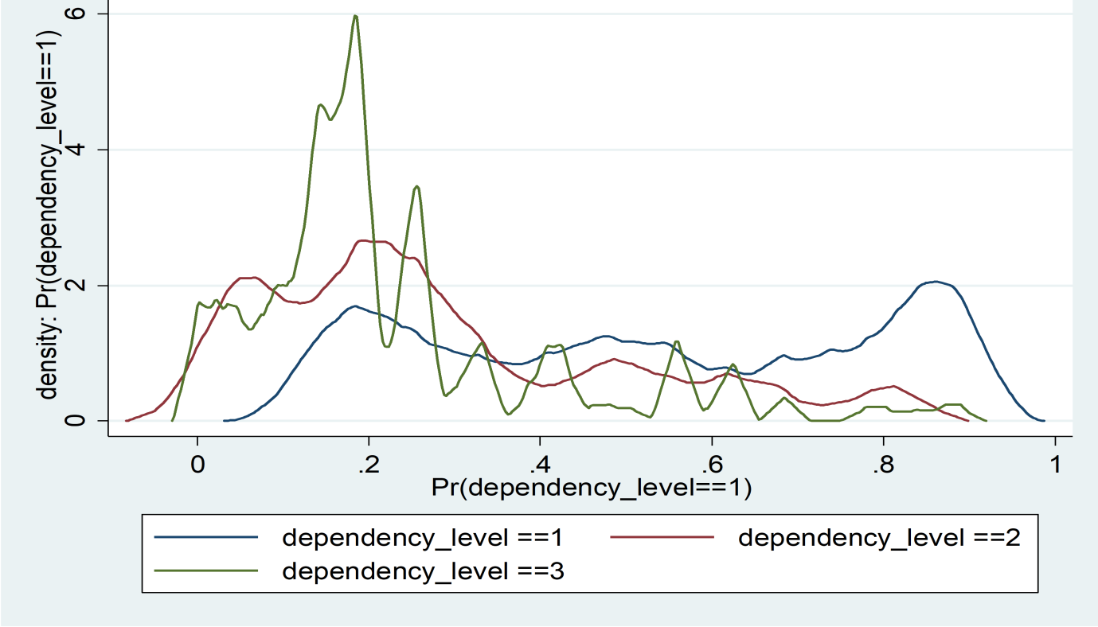
Figure 4.2: Conditional densities for probability of treatment on non-dependency category
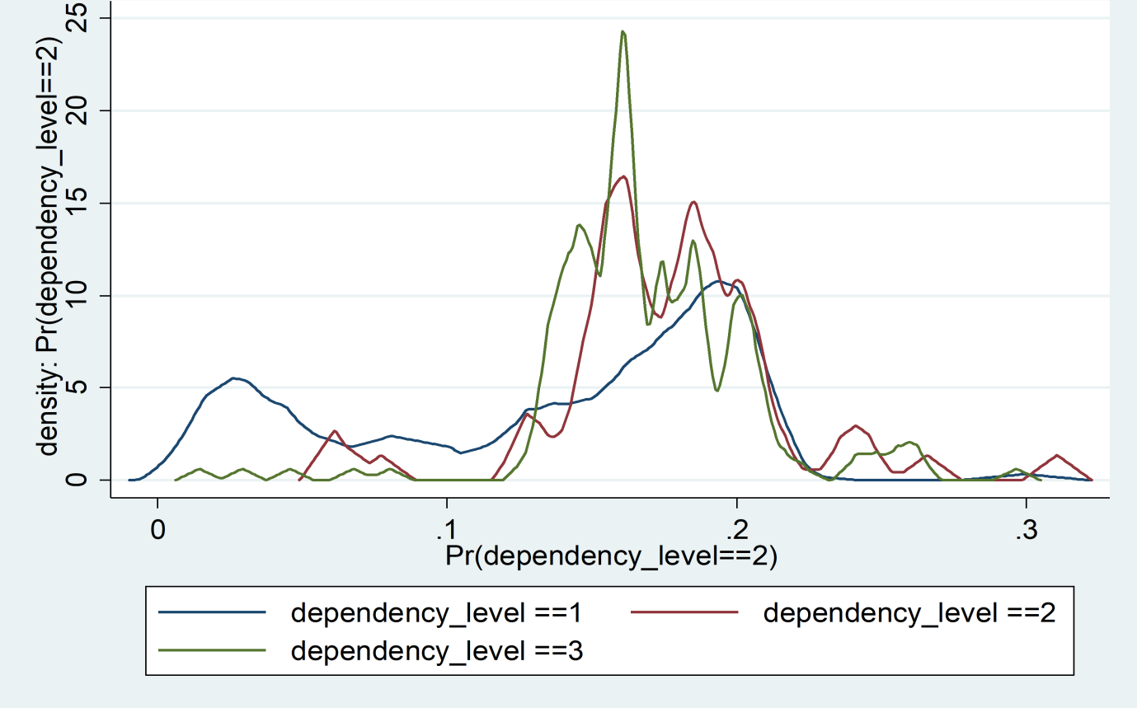Figure 4.3: Conditional densities for probability of treatment on low dependency category
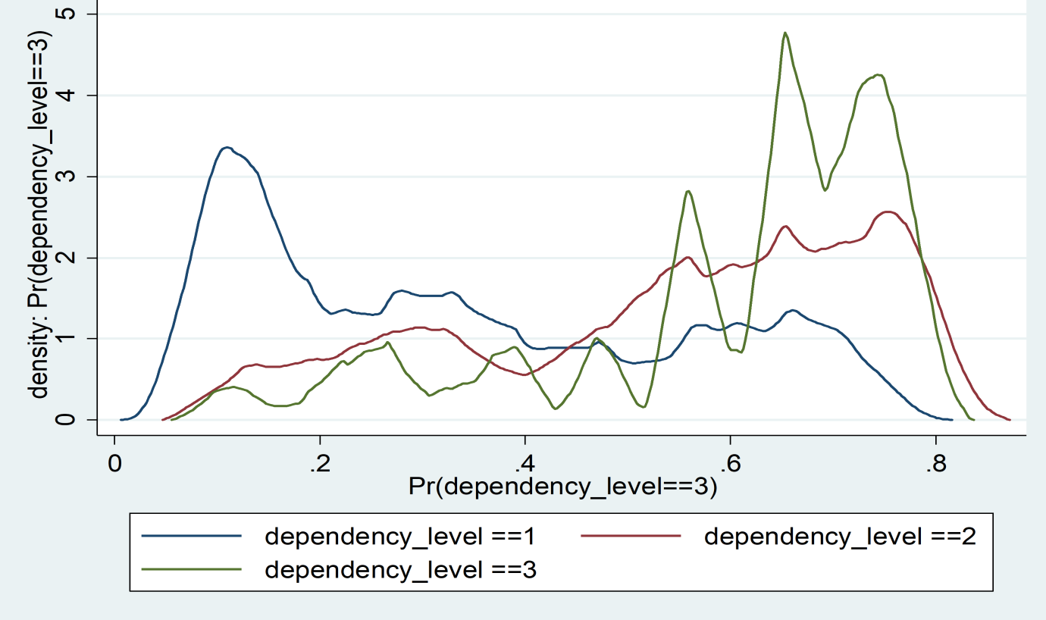
Figure 4.4: Conditional densities for probability of treatment on high dependency category
The overlap plots for non-dependency, low dependency, and high dependency were estimated from multinomial logit and are presented in Figures 4.2, 4.3, and 4.4, respectively. They denote the estimated density relating to the predicted probabilities for each particular dependency level conditional on the three dependency levels. The probability density for each dependency level was estimated by non-parametric kernel density with optimal bandwidth and triangular kernel in Stata (Cattaneo et al., 2013). In a condition where the estimated density shows sufficient mass too close to one or zero, then the predicted probabilities are near zero or one and indicate potential problematic cases. This implies that semiparametric estimators in finite samples will not perform well even when the conditional assumption is met (Busso et al., 2013). Neither of the graphs showed sufficient mass too close to zero or one, and hence the overlap assumption was satisfied. This is critical in ensuring an efficient inference procedure (Cattaneo et al., 2013).
Further, average treatment effects (ATE) on the levels of ocean fishery dependence on each potential welfare outcome were estimated, as presented in Table 4.12. The results indicated that the estimated treatment effects of moving between the different ocean fishery dependence levels were statistically significant from zero in all multidimensional poverty indices. Therefore, according to non-overlapping confidence intervals, the null hypothesis that the dependence levels have the same values will be rejected (Cattaneo, 2010). The results also revealed a consistent trend in which multidimensional poverty indices increased from non- dependence to high dependence. In particular, the increase in the household poverty score and multidimensional poverty intensity is between 5% and 24% as the dependence level moves from the lowest to the highest. This implies that an increase in poverty is associated with higher ocean fishery dependence. Marginalization and lack of alternative livelihood options for the fishing communities impede their ability to cope with shocks and fluctuation in fishery production. The finding is consistent with the work of Damania et al. (2020), who found that higher dependence on natural resources increases poverty because natural resources are increasingly under the threat of climate change, economic, and biological constraints and hence are subject to fluctuating returns. Moreover, Hakim (2016) reported high structural poverty in fishing communities, attributed to insufficient government policies, inequality, the disparity in revenue sharing approach, and limited marketing system.
Table 4.12: Multivalued average treatment effect (ATE) of treatment level m relative to treatment l (EIE)
 | Household poverty score |  | Multidimensional poverty dummy |  | Multidimensional poverty intensity
 | ATE | Std error | ATE | Std error | ATE | Std error
Non-dependency to low dependency | 0.0926*** | 0.0319 | 0.3874*** | 0 .0930 | 0.1901** | 0 .0454
Non-dependency to high dependency | 0.1673*** | 0.0266 | 0.4618*** | 0.0836 | 0.2430*** | 0 .0422
Low dependency to high dependency | 0.0747*** | 0 .0278 | 0.0745* | 0.0693 | 0.0529* | 0.0367
Note: *significant at 10%, **significant at 5%, ***significant at 1%
Even in the presence of low economic surplus, labour may still be attracted to ocean fishery in response to natural disasters. In a study done in East Africa, it was found that fishing communities are less likely to stop fishing amid uncertainty and a decline in fish stock (Batista et al. 2014). This could have been attributed to deprivation of productive assets and a lack of alternative employment opportunities. Therefore, the poverty of fishing communities is associated with income and unemployment. This makes them vulnerable to social pressure and climatic shocks and hence continues to get stuck in a poverty-natural resource trap. Although co-management and fisheries development programs have been introduced by the government of Kenya through its blue economy approach, lack of property rights and underperforming beach management units (BMUs) prevent poor households from achieving sustainable and resilient livelihoods.
Higher dependency is associated with a lower level of income diversification. This has hampered the ability of the ocean fishery to alleviate poverty. According to Kottutt et al. (2019), ceteris paribus households with diversified income activities have a better chance of improving their wellbeing. This implies that an increase in multi-dimension poverty indices could also have been attributed to the nature of the livelihood systems pursued by the households. Moreover, Ding et al. (2017) and Ebenezer and Abbyssinia (2018) reported that in Africa, fishery-dependent households had been found to have higher vulnerability due to limited societal capacity. Beckline et al. (2018) and Mukete et al. (2018) went further to explain that even when the natural resource-dependent households have the knowledge for alternative livelihood options, they are usually constrained by socio-cultural, institutional, and economic factors. Thus, natural resource livelihood strategy remains only viable for these particular households.
Further, in a study conducted in the Philippines, it was found that fishing communities have limited land rights that prevent them from diversifying into alternative livelihood options such as tourism (Fabinyi, 2019). Failure to maintain clear and sustainable land ownership rights impedes fishers from investment in buildings and capital-intensive structures. As a result, fishers could observe a rise in income but a limited increase in wealth (Fabinyi, 2019). Another study conducted in Viet Nam reported that lack of diversification to the next best alternative livelihood strategy among fishing-dependent households was contributed by the low level of job availability, low education level, and weak labour skills (Hanh & Boonstra, 2019). On the contrary, Andriesse (2019) reported that ocean fishery-dependent households are strongly attached to fishing, where they have a strong sense of purpose for the livelihood activity, making it difficult to diversify to non-ocean-based diversification strategies.

4.3.3 Heterogeneous treatment effect on the ocean fishery dependency
To determine the impact of ocean fishery dependence on inequality, the household poverty score was used (Alkire & Seth, 2014; Espinoza-Delgado & Klasen, 2018) in the estimation of the quantile treatment effect model. The results are presented in Table 4.13. The percentage change was calculated by expressing the average treatment effect (ATE) as the percentage of the Potential Outcome Means (POM) (Issahaku & Abdulai, 2020). The POM results are presented in the appendix in Table AIIId. The quantile treatment effect results indicated that increasing ocean fishery dependence positively affected household poverty scores across all quantiles, as indicated in Table 4.13. The higher dependence restricts both social and material well-being because returns from natural resources are extremely volatile (Edirisinghe, 2015).
Table 4.13: Quantile treatment effect of moving from l to m (EIE)
 | Q25 |  | Q50 |  | Q75
From l to m | QTE | % change | QTE | % change | QTE | % change
Non-dependence to low dependence | 0.0000 | 0.00 | 0.0208 | 9.99 | 0. 1042* | 41.70
Non-dependence to high dependence | 0.1250** | 150.06 | 0.0625* | 27.28 | 0.1667*** | 47.08
Low to high dependence | 0.125*** | 60.01 | 0.0417* | 15.40 | 0.0625* | 15.00
Note: *significant at 10%, **significant at 5%, ***significant at 1%
Based on percentage term, moving from non-dependency to low dependency was about 0%, 10%, and 42% in the 25th, 50th, and 75th quantiles of household poverty scores, respectively. This increases to approximately 150%, 27%, and 47% if the household moves from non-dependency to high dependency. The results indicated heterogeneity in household poverty scores across quantiles in all efficiency influence estimators (EIE), as indicated in Table 4.13 and Figures 4.4, 4.5, 4.6, and 4.7. This implies that some households, particularly from the lower quantile, benefited more from the ocean fishery compared to others due to higher investment in capital-intensive fishing gears such as ring nets and sport fishing facilities. Another possible explanation for this could be as a result of constraints enumerated by some dependent households, such as security of land tenure and access to credit that prevents them from investing in ocean fishery or even other entrepreneurial activities. Eggert et al. (2015) reported similar results in their assessment of the welfare effect on Lake Victoria fishery, where they found a simultaneous increase of real income with inequality. The finding suggested that growth in real income accrued to the wealthier households, with poor households having limited growth in their real income due to disparities in social and financial capital that ultimately contribute to material deprivations.
Social struggles among dependent households in relation to power and money have enhanced inequality (Bavinck et al., 2018). This has become evident as countries embrace the blue revolution because the ability to benefit from the ocean resource has also been transformed. The shift to high technological capability has improved fishing efficiency and enhanced capacity growth. However, the disparity in technology access has further escalated inequalities among fishers. The conducted interviews indicated that access to advanced technology among the dependent households was attributed to financial capital and social connections. They further noted that fishers with advanced equipment are more likely to earn higher returns compared to those using traditional methods such as foot fishing with lining. This implies how technology has contributed to inequality among dependent households.
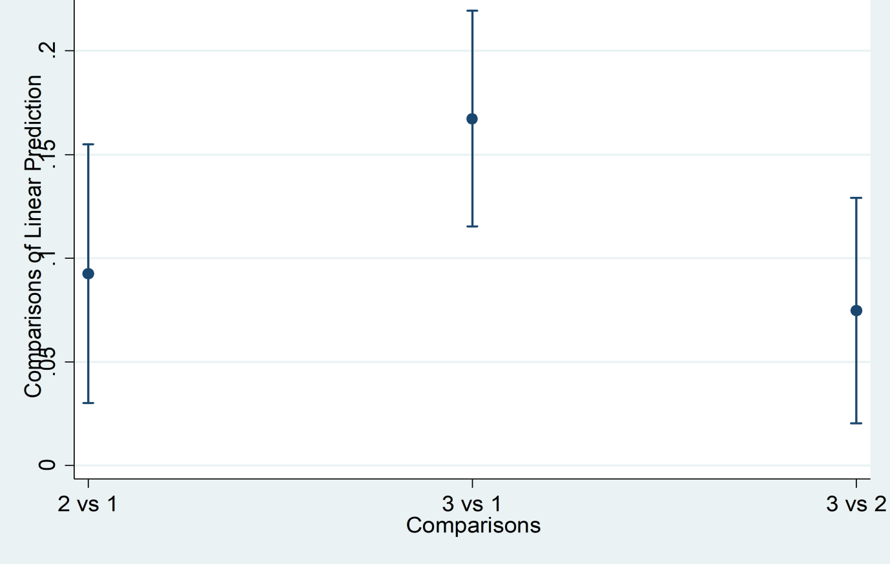
Figure 4.5: Full pairwise comparison of average treatment effect (ATE) with 95% CIs
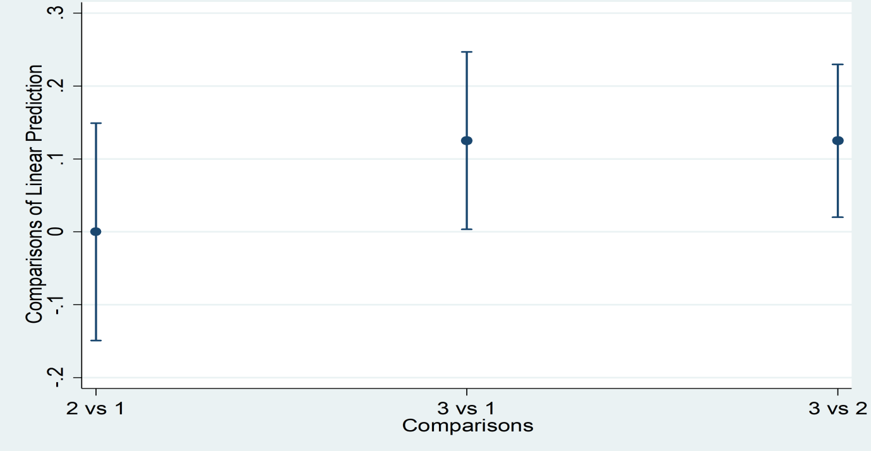
Figure 4.6: Average treatment effect comparisons in the 25th percentile with 95% CIs
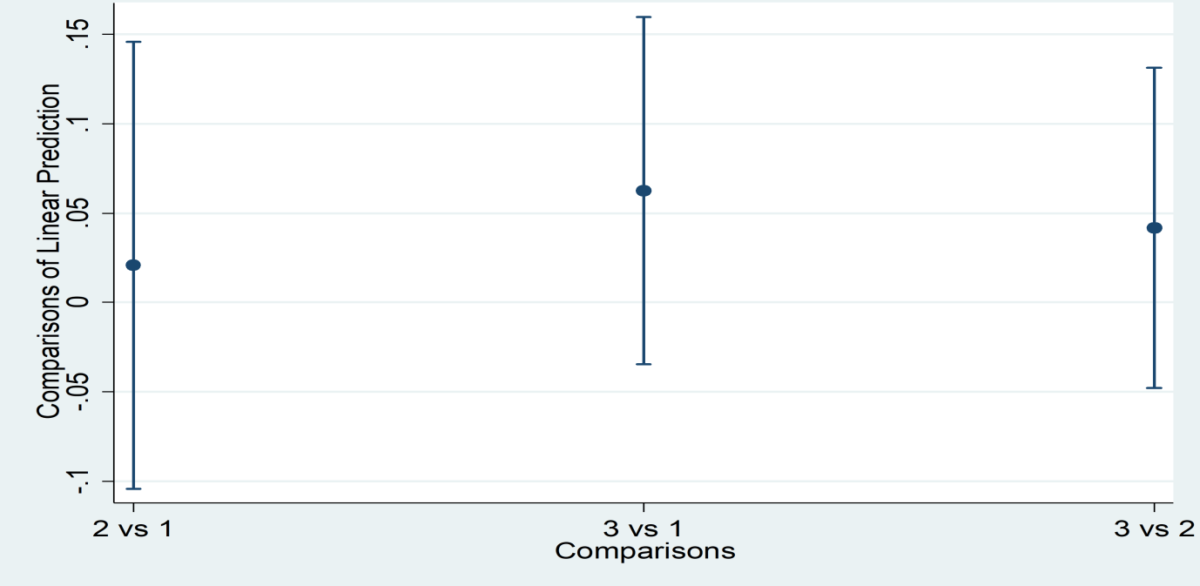
Figure 4.7: Average treatment effect comparisons in the 50th percentile with 95% CIs
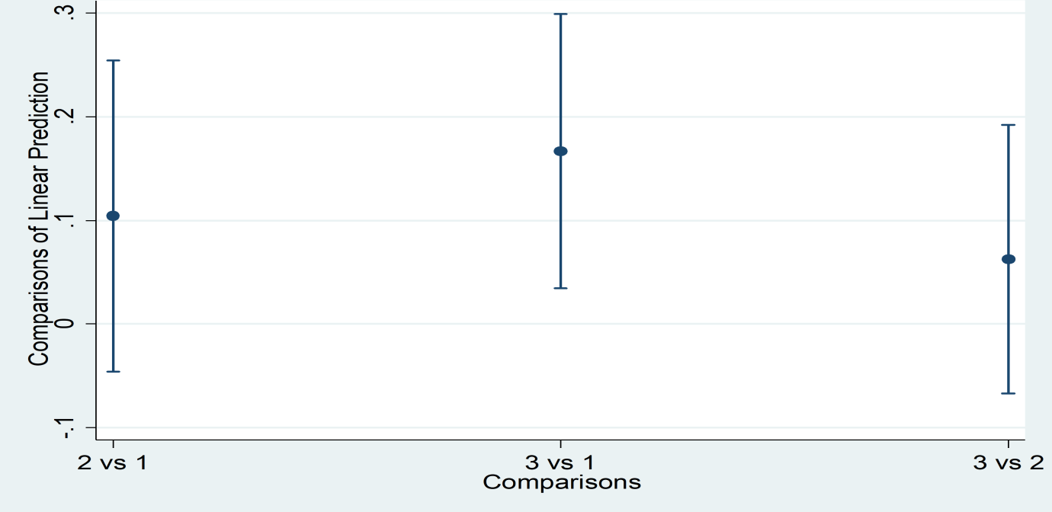
Figure 4.8: Average treatment effect comparisons in the 75th percentile with 95% CIs
The margins plot for pairwise comparisons for full sample and 25th, 50th, and 75th percentile of the household poverty score are presented in Figures 4.5, 4.6, 4.7, and 4.8, respectively. From the figures, 2 vs 1 denotes moving from non-dependency to low dependency level, 3 vs 1 entails moving from non-dependency to high dependency, and 3 vs 2 represents moving from low dependency to high dependency. The figures depict graphical representations of quantile treatment effect as presented and discussed in Table 4.13.
The study also estimated the quantile treatment effect on per-capita income, as presented in Table AIIIe. The results indicated that increasing ocean fishery dependence positively influenced per capita income across all quantiles. The results implied that ocean fishery is an important source of livelihood, and as such, it has the potential for improving human welfare through increased income. It is based on this notion that households pursued specialist fishing in the region as a means of enhanced commercialization. However, as ocean fishery dependence increased, the per-capita income increased at a diminishing rate across all quantiles. This could have been attributed to declining fish biomass, particularly after trawlers and mining companies start to operate in the Indian Ocean in the coastal region of Kenya. The results also indicated that there was heterogeneity in income gains across all quantiles, implying a possible reason why the households were experiencing a positive relationship between ocean fishery dependence and inequality.

4.3.4. Dose response function
The impact of ocean fishery dependence on poverty outcomes was also examined using the dose-response function. Out of the 384 sample, 261 households were participating in ocean fishery and related activities, representing approximately 68% for which was adequately enough to provide data for estimation of dose-response function on the outcome variables. Eq. 23 was used to estimate the dose-response function. However, the estimated regression coefficients were not discussed since they lack direct interpretation (Hirano & Imbens, 2004), but they are reported in the appendix section in Table AIIIh. Further, based on the literature on the effect of natural resource dependence on poverty and inequality, the study assumed that the covariates presented in Table AIIIg are good predictors of the treatment levels; hence the un-confoundedness assumption was satisfied (Issahaku & Abdulai, 2020). Also, the common support condition was met because almost all the variables in each treatment level balance out except the group membership and price since they had a t-value of greater than 1.282 (Bia & Mattei, 2008). The results of the dose-response function for multidimensional poverty intensity, household poverty score, and per capita income are presented in Figure 4.9, 4.10, and 4.11, respectively.
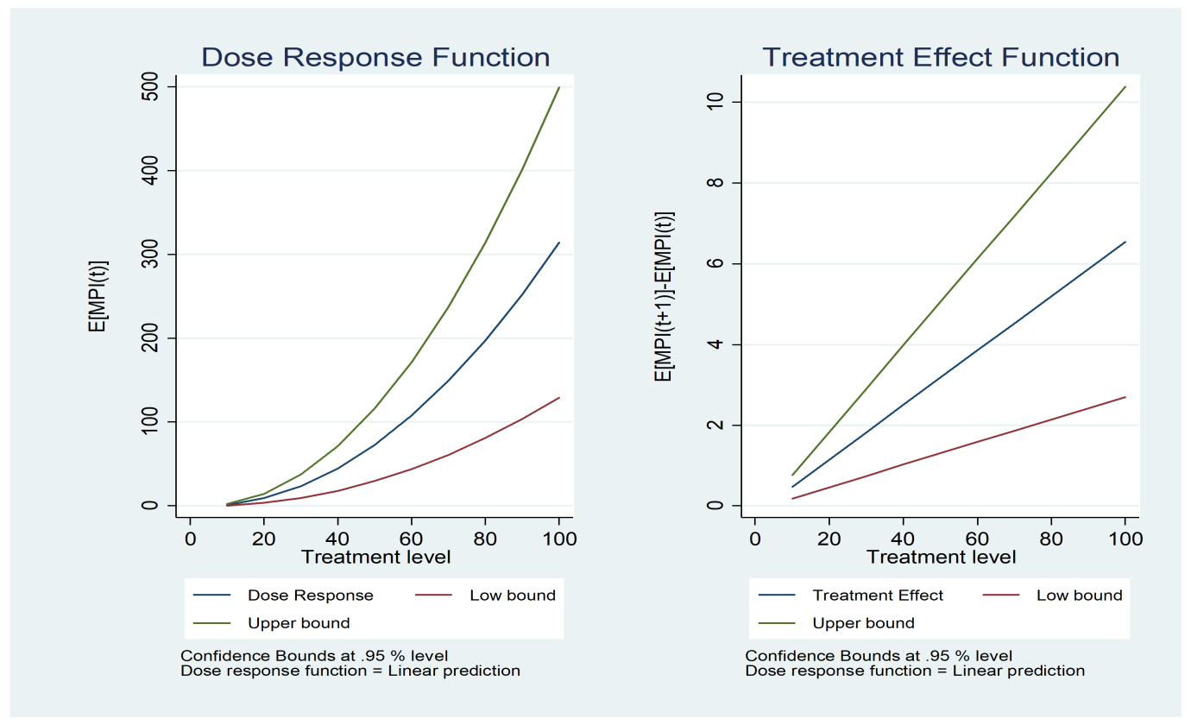
Figure 4.9: Dose response function and corresponding marginal treatment effect estimates on MPI
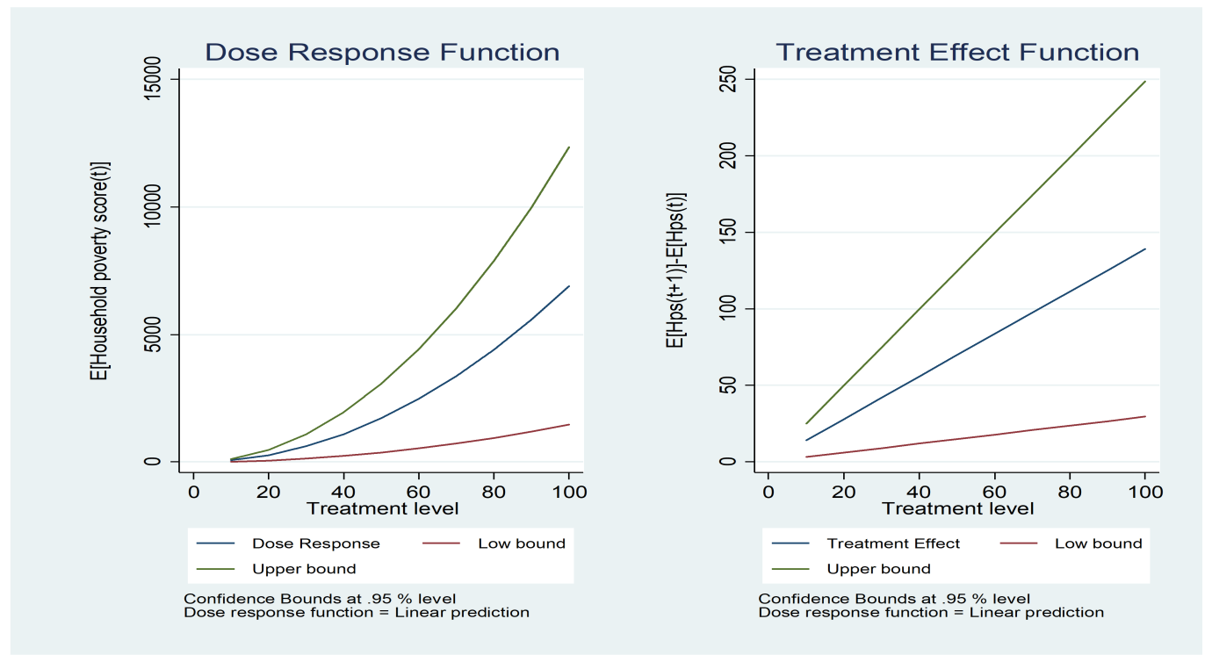
Figure 4.10: Dose response function and corresponding marginal treatment effect estimates on Household poverty score
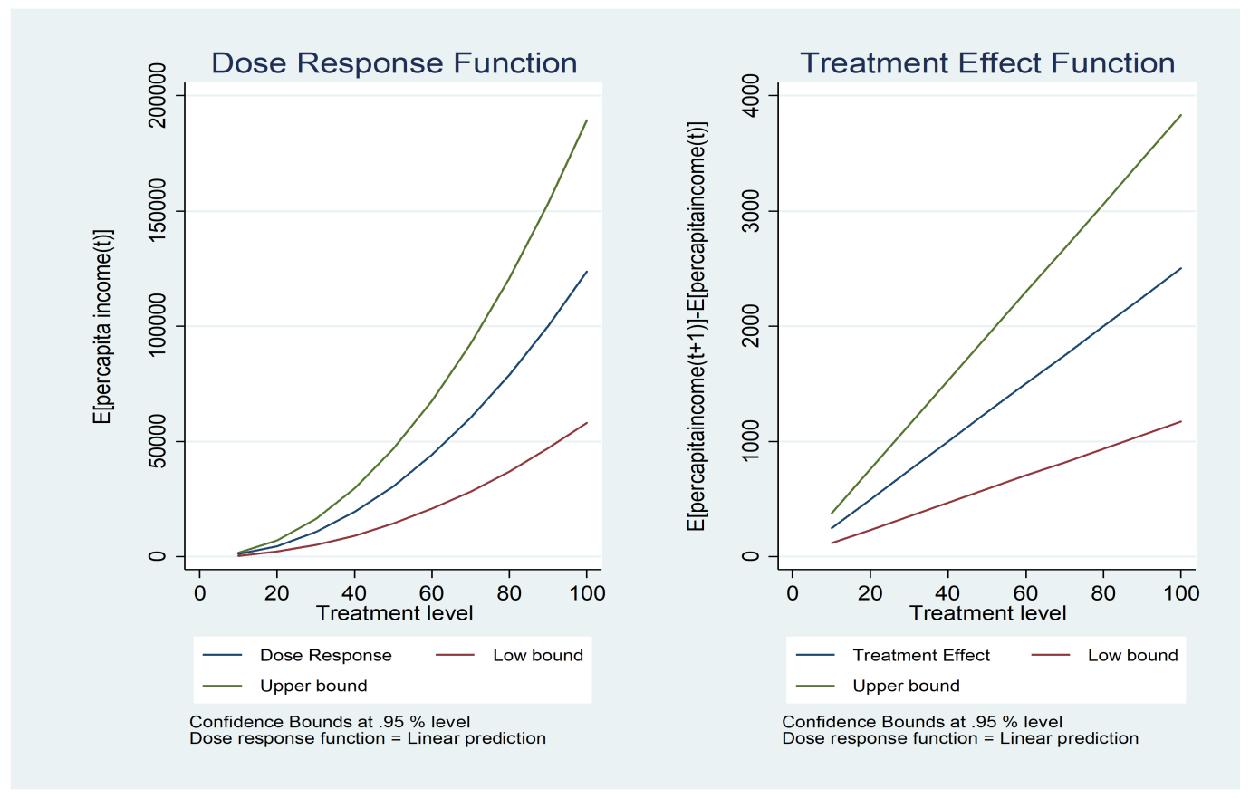
Figure 4.11: Dose response function and corresponding marginal treatment effect estimates on per capita income
The dose-response function results indicated a positive and linear relationship between increasing ocean fishery dependence and the poverty outcomes, as indicated in Figure 4.9 and 4.10. This suggests that as ocean fishery dependence increases, the household’s probability of being multi-dimensionally poor increases. The possible explanation for this is that higher dependence is mostly associated with higher climatic and idiosyncratic shocks, lower entrepreneurial behaviors, and poor access to effective fishing technology. Neiland and Béné (2013) reported that the linear relationship between poverty and fishery is attributed to institutional factors and fishing entitlement failures. Thus, the possibility of using ocean fishery as a pathway out of poverty relies not only on conserving fish stocks but also on shaping the household’s command of the resource. Given that ocean fishery dependence is associated with increasing income, as indicated in Figure 4.11, effective management systems are critical to eliminate inequality and maximise fishing returns that will subsequently enhance food security and alleviate poverty.

CHAPTER FIVE

CONCLUSION AND RECOMMENDATIONS

5.1 Conclusions
The study aimed at contributing to the achievement of blue economy sub-themes through sustainable ocean fishery dependence and livelihood among households in Coastal lowlands of Kenya. From the analysis of the objective of this study, three conclusions were identified.
i) The result indicated that ocean fishery was the highest livelihood option exhibiting gender differences. Ocean fishery and related activities was a male-dominated livelihood option. However, females were active in fish trading and small-scale processing since it required low capital and unskilled labour.
ii) Ocean fishery was affected by socio-economic and institutional factors, as well as covariates and idiosyncratic shocks. Ocean fishery dependence was positively and significantly influenced by the agricultural productive assets, social network, flood, and fish price shock. Moreover, education level, access to credit, and security of tenure were found to have a negative and significant effect on ocean fishery dependence.
iii) Higher ocean fishery dependency was associated with perpetuating poverty and inequality in the coastal area. This could have been attributed to higher dependence on one livelihood option, which reduces households’ adaptive capacity and resilience to covariates and idiosyncratic shocks. Kenyan coastal households that are dependent on ocean fishery are more vulnerable to shocks due to lack of economic diversification, poor functioning financial systems, and historical injustices of land. On the contrary, when ocean fishery income is supplemented by other livelihoods income, the result suggests that there was a reduction in inequality. This implies that for ocean fishery income to reduce inequality or even alleviate poverty, livelihood diversification is critical.

5.2 Recommendations
The findings of the study are critical for policy design, effective marine conservation, and rural development. Given that many households depend on marine fishery and related activities, livelihood development programmes should be directed to social and human capital to increase access to credit and entrepreneurial activities. Public investments that stimulate accessibility to alternative diversification options are critical for facilitating sustainable livelihood strategies that will promote food security, alleviate poverty, and conserve marine life. Finally, it is worth noting that the achievement of the blue economy approach relies on inclusivity and environmental sustainability. This could be achieved by leveraging the marine resource to enhance economic opportunities along Kenya’s coastal region.
The ocean fishery is affected by climatic, economic, and institutional constraints; therefore, government intervention is recommended to improve the wellbeing and overall resilience of dependent households. This calls for infrastructural development, well-functioning markets, and improved extension services. Also, welfare policies need to take into account household heterogeneities in marine policy formulation. The majority of the ocean fishery-dependent households are poor, raising the issue of disparity in the distribution of benefits from the ocean resource. Therefore, a balanced approach to marine management should be implemented and ensure that poor fishers are neither marginalized nor exploited by investors in ocean fishery. This will be vital in contributing to an inclusive economy as one of the major sub themes of the blue economy approach and reduce their exposure to climatic, economic, and institutional constraints.
Further, the nexus between marine fishery dependence, poverty and inequality suggests that marine resource needs to be conserved for preservation and enhancing biomass, which will improve productivity and provide pathways out of poverty. Ocean fishery should, therefore, be closely monitored, and if there is a lack of compliance or use of highly efficient gears such as trawlers, one needs to be banned. This implies that the government should support beach management units through resources and an oversight role for improving the welfare of the dependent households. In particular, a clear stakeholder mapping coupled with the effective institutional and regulatory framework is critical to provide incentives to the dependent households and reduce externalities such as pollution and habitat loss. As a result, the ocean fishery resource will be able to contribute to sustainable dependence through social and economic benefits, maintaining diversity, productivity, and resilience of the marine ecosystem, and encouraging the use of clean technology.

5.3 Areas for further research
Further research on the study involves evaluating the vulnerability and resilience among the ocean fishery-dependent households to climatic and idiosyncratic shocks. This will help in finding the appropriate policy interventions in promoting sustainable livelihood strategies, which will alleviate poverty and inequality and contribute to the achievement of blue economy goals. Moreover, the research could be expanded to include the analysis of natural resource governance and livelihood nexus among the ocean fishery-dependent households. This is critical to identify appropriate ocean management practices and define effective local institutional arrangements that will enhance the outcome of the ocean fishery and the achievement of sustainable ocean management.

REFERENCES
Abunge, C., Coulthard, S., & Daw, T. M. (2013). Connecting marine ecosystem services to human well-being: Insights from participatory well-being assessment in Kenya. Ambio, 42(8), 1010-1021. https://doi.org/10.1007/s13280-013-0456-9.
Ahmed, N., & Thompson, S. (2019). The blue dimensions of aquaculture: A global synthesis. Science of The Total Environment, 652, 851-861. https://doi.org/10.1016/j.scitotenv.2018.10.163.
Alexander, S., Bodin, Ö., & Barnes, M. (2018). Untangling the drivers of community cohesion in small-scale fisheries. International Journal of the Commons, 12(1), 519-547. https://doi.org/10.18352/ijc.843.
Al-Jabri, O. M. A. R., Collins, R., Sun, X., Omezzine, A., & Belwal, R. (2013). Determinants of small-scale fishermen's income on Oman's Batinah Coast. Marine Fisheries Review, 75(3), 21-32. https://doi.org/10.18352/ijc.843
Ali, A. (2018). Forest-based livelihoods, income, and poverty: empirical evidence from the Himalayan region of rural Pakistan. Journal of Rural Studies, 57, 44-54. https://doi.org/10.1016/j.jrurstud.2017.10.001.
Alkire, S., & Foster, J. (2011). Counting and multidimensional poverty measurement. Journal of Public Economics, 95(7-8), 476-487. https://doi.org/10.1016/j.jpubeco.2010.11.006.
Alkire, S., & Santos, M.E. (2013) Measuring acute poverty in the developing world: Robustness and scope of the multidimensional poverty index, OPHI Working Paper 59. Oxford: University of Oxford, 1-48. https://doi.org/10.2139/ssrn.2296819.
Alkire, S., & Suman, S. (2014). Inequality among the mpi poor, and regional disparity in multidimensional poverty: Levels and trends. OPHI Briefing 25. Oxford: University of Oxford, 1-8. https://doi.org/10.35648/20.500.12413/11781/ii014.
Alkire, S., & Seth, S. (2014). Measuring and decomposing inequality among multidimensionally poor using ordinal data: A counting approach. OPHI Working Papers 68. Oxford: University of Oxford, 1-41. https://doi.org/10.35648/20.500.12413/11781/ii030
Allan-Degen, A., Hoorweg, J., & Wangila, B. C. (2010). Fish traders in artisanal fisheries on the Kenyan Coast. Journal of Enterprising Communities: People and Places in the Global Economy, 4(4), 296-311. https://doi.org/10.1108/17506201011086101.
Andrew, N. L., Béné, C., Hall, S. J., Allison, E. H., Heck, S., & Ratner, B. D. (2007). Diagnosis and management of small-scale fisheries in developing countries. Fish and Fisheries, 8(3), 227-240. https://doi.org/10.1079/9781845936075.0035.
Andriesse, E. (2019). Local differentiation in diversification challenges in eleven coastal villages in Iloilo Province, Philippines. The European Journal of Development Research, 32, 652–671. https://doi.org/10.1057/s41287-019-00233-3.
Angelsen, A., Jagger, P., Babigumira, R., Belcher, B., Hogarth, N. J., Bauch, S., Borner, J., Smith-Hall, C., & Wunder, S. (2014). Environmental income and rural livelihoods: A global-comparative analysis. World Development, 64 (S1), S12-S28. https://doi.org/10.17528/cifor/data.00002.
Ayuya, O. I., Gido, E. O., Bett, H. K., Lagat, J. K., Kahi, A. K., & Bauer, S. (2015). Effect of certified organic production systems on poverty among smallholder farmers: Empirical evidence from Kenya. World Development, 67, 27-37. https://doi.org/10.1016/j.worlddev.2014.10.005.
Babulo, B., Muys, B., Nega, F., Tollens, E., Nyssen, J., Deckers, J., & Mathijs, E. (2009). The economic contribution of forest resource use to rural livelihoods in Tigray, Northern Ethiopia. Forest Policy and Economics, 11(2), 109-117. https://doi.org/10.1007/s13280-013-0456-9.
Batista, V. S., Fabré, N. N., Malhado, A. C., & Ladle, R. J. (2014). Tropical artisanal coastal fisheries: Challenges and future directions. Reviews in Fisheries Science & Aquaculture, 22(1), 1-15. https://doi.org/10.1080/10641262.2013.822463.
Bavinck, M., Jentoft, S., & Scholtens, J. (2018). Fisheries as social struggle: A reinvigorated social science research agenda. Marine Policy, 94, 46-52. https://doi.org/10.1016/j.marpol.2018.04.026.
Beckline, M., Yujun, S., Etongo, D., Saeed, S., & Mannan, A. (2018). Assessing the drivers of land use change in the rumpi hills forest protected area, Cameroon. Journal of Sustainable Forestry, 37(6), 592-618. https://doi.org/10.1080/10549811.2018.1449121.
Belhabib, D., Sumaila, U. R., & Le Billon, P. (2019). The fisheries of Africa: Exploitation, policy, and maritime security trends. Marine Policy, 101, 80-92. https://doi.org/10.1016/j.marpol.2018.12.021.
Ben-Arieh, A. & Frønes, I. (2011). Taxonomy for child well-being indicators: A framework for the analysis of the well-being of children. Childhood, 18(4), 460-476. https://doi.org/10.1177/0907568211398159.
Béné, C., & Friend, R. M. (2011). Poverty in small-scale fisheries: Old issue, new analysis. Progress in Development Studies, 11(2), 119-144. https://doi.org/10.1177/146499341001100203
Béné, C., Arthur, R., Norbury, H., Allison, E. H., Beveridge, M., Bush, S., & Thilsted, S. H. (2016). Contribution of fisheries and aquaculture to food security and poverty reduction: Assessing the current evidence. World Development, 79, 177-196. https://doi.org/10.1016/j.worlddev.2015.11.007.
Béné, C., Macfadyen, G., & Allison, E. H. (2007). Increasing the contribution of small-scale fisheries to poverty alleviation and food security (No. 481). Food & Agriculture Organization.
Benkenstein, A. (2018). Prospects for the Kenyan blue economy, 1-9. Available at https://www.africaportal.org/publications/prospects-kenyan-blue-economy/ Accessed on 22nd March 2019.
Bia, M., & Mattei, A. (2008). A Stata package for the estimation of the dose-response function through adjustment for the generalized propensity score. The Stata Journal, 8(3), 354-373. https://doi.org/10.1177/1536867x0800800303.
Bia, M., & Mattei, A. (2012). Assessing the effect of the amount of financial aids to Piedmont firms using the generalized propensity score. Statistical Methods & Applications, 21(4), 485-516. https://doi.org/10.1007/s10260-012-0193-4.
Busso, M., DiNardo, J., & McCrary, J. (2014). New evidence on the finite sample properties of propensity score reweighting and matching estimators. Review of Economics and Statistics, 96(5), 885-897. https://doi.org/10.1162/rest_a_00431.
Carter, C., & Garaway, C. (2014). Shifting tides, complex lives: the dynamics of fishing and tourism livelihoods on the Kenyan Coast. Society & Natural Resources, 27(6), 573-587. https://doi.org/10.1080/08941920.2013.842277.
Cattaneo, M. D. (2010). Efficient semiparametric estimation of multi-valued treatment effects under ignorability. Journal of Econometrics, 155(2), 138-154. https://doi.org/10.1016/j.jeconom.2009.09.023.
Cattaneo, M. D., Drukker, D. M., & Holland, A. D. (2013). Estimation of multivalued treatment effects under conditional independence. The Stata Journal, 13(3), 407-450. https://doi.org/10.1177/1536867x1301300301.
CGOK. (2013). First Kilifi County Integrated Development Plan 2013- 2017, Finance and Economic Planning, County Government of Kilifi, 1-296.
CGOK. (2018). Kilifi County Integrated Development Plan 2018 -2022, Economic Planning and Finance, County Government of Kilifi, 1-370.
Chegere, M. J. (2018). Post-harvest losses reduction by small-scale maize farmers: The role of handling practices. Food Policy, 77, 103-115. https://doi.org/10.1016/j.foodpol.2018.05.001.
Cinner, J. E., McClanahan, T. R., Graham, N. A., Daw, T. M., Maina, J., Stead, S. M., Wamukota, A., Brown, K., & Bodin, Ö. (2012). Vulnerability of coastal communities to key impacts of climate change on coral reef fisheries. Global Environmental Change, 22(1), 12-20. https://doi.org/10.1016/j.gloenvcha.2011.09.018.
Clark, D. A. (2005). Sen's capability approach and the many spaces of human well-being. The Journal of Development Studies, 41(8), 1339-1368. https://doi.org/10.1080/00220380500186853.
Cochran, W. G. (1977). Sampling techniques. John Wiley & Sons. New York.
Coulthard, S. (2012). Can we be Both Resilient and Well, and what Choices do People have? Incorporating Agency into the Resilience Debate from a Fisheries Perspective. Ecology and Society, 17(1):4. https://doi.org/10.5751/es-04483-170104.
Damania, R., Joshi, A., & Russ, J. (2020). India’s forests–stepping stone or millstone for the poor? World Development, 125, 1-12. https://doi.org/10.1016/j.worlddev.2018.11.007.
Daoud, J. I. (2017). Multicollinearity and regression analysis. In Journal of Physics: Conference Series. IOP Publishing, 1-7. https:// doi :10.1088/1742-6596/949/1/012009.
Daw, T. M., Cinner, J. E., McClanahan, T. R., Brown, K., Stead, S. M., Graham, N. A., & Maina, J. (2012). To fish or not to fish: Factors at multiple scales affecting artisanal fishers' readiness to exit a declining fishery. PloS One, 7(2), e31460. https://doi.org/10.1371/journal.pone.0031460.
Ding, Q., Chen, X., Hilborn, R., & Chen, Y. (2017). Vulnerability to impacts of climate change on marine fisheries and food security. Marine Policy, 83, 55-61. https://doi.org/10.1016/j.marpol.2017.05.011.
Do, T. L., Nguyen, T. T., & Grote, U. (2019). Nonfarm employment and household food security: Evidence from panel data for rural Cambodia. Food Security, 11(3), 703-718. https://doi.org/10.1007/s12571-019-00929-8.
Ebenezer, M., & Abbyssinia, M. (2018). Livelihood diversification and its effect on household poverty in Eastern Cape Province, South Africa. The Journal of Developing Areas, 52(1), 235-249. https://doi.org/10.1353/jda.2018.0014.
Edirisinghe, J. C. (2015). Smallholder farmers’ household wealth and livelihood choices in developing countries: A Sri Lankan case study. Economic Analysis and Policy, 45, 33-38. https://doi.org/10.1016/j.eap.2015.01.001.
Eggert, H., Greaker, M., & Kidane, A. (2015). Trade and resources: Welfare effects of the Lake Victoria fisheries boom. Fisheries Research, 167, 156-163. https://doi.org/10.1016/j.fishres.2015.02.015.
Espinoza-Delgado, J., & Klasen, S. (2018). Gender and multidimensional poverty in Nicaragua: An individual based approach. World Development, 110, 466-491. https://doi.org/10.2139/ssrn.3016287.
Fabinyi, M. (2019). The role of land tenure in livelihood transitions from fishing to tourism. Maritime Studies, 1-11. https://doi.org/10.1007/s40152-019-00145-2.
Fabinyi, M., Dressler, W. & Pido, M. (2019). Access to fisheries in the maritime frontier of Palawan Province, Philippines. Singapore Journal of Tropical Geography, 40(1), 92-110. https://doi.org/10.1111/sjtg.12260.
FAO. (2013). The State of Food and Agriculture 2013. Rome: FAO. Available online at http://www.fao.org/ publications/sofa/2013/en/. Accessed on 25th march 2019.
FAO. (2014). The State of Food and Agriculture 2014. Rome: FAO. Available online at http://www.fao.org/3/a-i3720e.pdf. Accessed on 25th march 2019.
FAO. (2016). Fishery and Aquaculture Country Profiles: The Republic of Kenya. Available online at http://www.fao.org/fishery/facp/KEN/en. Accessed on 28th march 2019.
Farbmacher, H., & Kögel, H. (2017). Testing under a special form of heteroscedasticity. Applied Economics Letters, 24(4), 264-268. https://doi.org/10.1080/13504851.2016.1181827.
Fehr, E., & Leibbrandt, A. (2008). Cooperativeness and impatience in the tragedy of the commons. IZA- Institute of Labor Economics, Bonn (IZA Discussion Papers, No. 3625). https://doi.org/10.2139/ssrn.1262202.
Ferreira, F. H., & Ravallion, M. (2008). Global poverty and inequality: a Review of the evidence. The World Bank.
Foster, J., Greer, J., & Thorbecke, E. (1984). A class of decomposable poverty measures. Econometrica: Journal of the Econometric Society, 52(3), 761-766. https://doi.org/10.2307/1913475.
Funge‐Smith, S., & Bennett, A. (2019). A fresh look at inland fisheries and their role in food security and livelihoods. Fish and Fisheries, 20(6), 1176-1195. https://doi.org/10.1111/faf.12403.
Garekae, H., Thakadu, O. T., & Lepetu, J. (2017). Socio-economic factors influencing household forest dependency in Chobe Enclave, Botswana. Ecological Processes, 6(1), 40. https://doi.org/10.1186/s13717-017-0107-3.
Githunguri, F. W. (2017). Evaluation of the mandate of the relevant institutions in addressing the squatter problem in Kenya (Doctoral dissertation, Strathmore University), 1-74. Available online at https://su-plus.strathmore.edu/bitstream/handle /11071/5224/Evaluation%20of%20the. %20mandate%20of%20the%20relevant%20 institutions.pdf?sequence=1&isAllowed=y. Accessed on 25th march 2019
GOK. (2011). National Food and Nutrition Security Policy. Available online at https://extranet.who.int/nutrition/gina/sites/default/files/KEN%202011%20National%20Food%20and%20Nutrition%20Security%20Policy%5B1%5D.pdf. Accessed on 6th April 2019.
Gunatilake, H., Wickramasinghe, W., & Abeygunawardena, P. (2012). Time preference and natural resource use by local communities: The case of Sinharaja forest in Sri Lanka. Sri Lankan Journal of Agricultural Economics, 10(0), 31-60. https://doi.org/10.4038/sjae.v10i0.4590.
Hakim, M. (2016). Social structure and poverty in the fishing community at Pandang-Pandang, Jeneponto in South Sulawesi Province. Mediterranean Journal of Social Sciences, 7(1 S1), 188. https://doi.org/10.5901/mjss.2016.v7n1s1p188.
Hanh, T. T. H., & Boonstra, W. J. (2019). What prevents small-scale fishing and aquaculture households from engaging in alternative livelihoods? A case study in the Tam Giang lagoon, Viet Nam. Ocean & Coastal Management, 182, 1-11. https://doi.org/10.1016/j.ocecoaman.2019.104943
Hirano, K., & Imbens, G. W. (2004). The propensity score with continuous treatments. Applied Bayesian Modeling and Causal Inference from Incomplete-data Perspectives, 226164, 73-84. https://doi.org/10.1198/016214504000001187.
Islam, M. M., & Chuenpagdee, R. (2013). Negotiating risk and poverty in mangrove fishing communities of the Bangladesh Sundarbans. Maritime Studies, 21(7), 1-20. https://doi.org/10.1186/2212-9790-12-7.
Issahaku, G., & Abdulai, A. (2019). Can farm households improve food and nutrition security through adoption of climate-smart practices? Empirical evidence from Northern Ghana. Applied Economic Perspectives and Policy. 42(3), 559-579. https://doi.org/10.1093/aepp/ppz002.
Issahaku, G., & Abdulai, A. (2020). Household welfare implications of sustainable land management practices among smallholder farmers in Ghana. Land Use Policy, 94, 1-14. https://doi.org/10.1016/j.landusepol.2020.104502.
Jeyanthi, P., Balasubramaniam, S., & Jeeva, J. C. (2016). Socio-economic status of fishermen operating FRP Boats in Nagapattinam District, Tamil Nadu: A special focus on poverty and income inequality. Indian J. Fish, 63(2), 151-153. https://doi.org/10.21077/ijf.2016.63.2.41238-24.
Jin, S., Waibel, H., Min, S., & Huang, J. (2018). Livelihood responses of smallholder farmers in Southwest China to the decline in rubber prices. In 30th International Conference of Agricultural Economists Vancouver, USA, 1-26.
Joos-Vandewalle, S., Wynberg, R., & Alexander, K. A. (2018). Dependencies on natural resources in transitioning urban centers of Northern Botswana. Ecosystem Services, 30, 342-349. https://doi.org/10.1016/j.ecoser.2018.02.007.
Kabubo-Mariara, J. (2013). Forest-poverty nexus: Exploring the contribution of forests to rural livelihoods in Kenya. In Natural Resources Forum, 37, 177-188. https://doi.org/10.1111/1477-8947.12003.
Kabubo-Mariara, J., Wambugu, A., & Musau, S. (2011). Multidimensional poverty in Kenya: Analysis of maternal and child wellbeing. PEP PMMA, 12, 1-59. https://doi.org/10.2139/ssrn.1935594.
Kakwani, N., & Silber, J. (Eds.). (2008). The many dimensions of poverty. Palgrave Macmillan.
Kebebe, E., & Shibru, F. (2017). Impact of alternative livelihood interventions on household welfare: Evidence from rural Ethiopia. Forest Policy and Economics, 75, 67-72. https://doi.org/10.1016/j.forpol.2016.12.001.
KC, K. B., Seng, R., & Fraser, E. (2019). Should I stay or should i go? Fishers’ ability and willingness to adapt to environmental change in Cambodia's Tonle Sap Lake. Fisheries Management and Ecology, 26(3), 211-223. https://doi.org/10.1111/fme.12341.
Khandker, S. R., & Haughton, J. H. (2009). Handbook on poverty and inequality. World Bank, 1-405.
Kimengsi, J. N., Pretzsch, J., Kechia, M. A., & Ongolo, S. (2019). Measuring livelihood diversification and forest conservation choices: Insights from rural Cameroon. Forests 2019, 10(81), 1-16. https://doi.org/10.3390/f10020081.
Kleih, U., Linton, J., Marr, A., Mactaggart, M., Naziri, D., & Orchard, J. E. (2013). Financial services for small and medium-scale aquaculture and fisheries producers. Marine Policy, 37, 106-114. https://doi.org/10.1016/j.marpol.2012.04.006.
Klopp, J. M., & Lumumba, O. (2017). Reform and counter-reform in Kenya's land governance. Review of African Political Economy, 44(154), 577-594. https://doi.org/10.1080/03056244.2017.1367919.
Kottutt, S. K., Sumukwo, J. Y., & Omondi, P. (2020). Forest ecosystem resources for alleviating household poverty in Eastern Mau, Kenya. Africa Environmental Review Journal, 3(2), 1-19.
Kyando, M. T., Nyahongo, J. W., Røskaft, E. & Nielsen, M. R. (2019). Household reliance on environmental income in the Western Serengeti Ecosystem, Tanzania. Environment and Natural Resources Research, 9(1), 54-63. https://doi.org/10.5539/enrr.v9n1p54.
Langat, D. K., Maranga, E. K., Aboud, A. A. & Cheboiwo, J. K. (2016). Role of forest resources to local livelihoods: The case of East Mau Forest Ecosystem, Kenya. International Journal of Forestry Research 2016, 1-10. https://doi.org/10.1155/2016/4537354.
Lepcha, L. D., Shukla, G., Pala, N. A., Vineeta, Pal, P. K. & Chakravarty, S. (2019). Contribution of NTFPs on livelihood of forest-fringe Communities in Jaldapara National Park, India. Journal of Sustainable Forestry, 38(3), 213-229. https://doi.org/10.1080/10549811.2018.1528158.
Li, Q., & Zander, P. (2019). Resilience building of rural livelihoods in PES programmes: A case study in China’s Loess Hills. Ambio, 1-24. https://doi.org/10.1007/s13280-019-01236-4.
Linden, A., Uysal, S. D., Ryan, A., & Adams, J. L. (2016). Estimating causal effects for multivalued treatments: A comparison of approaches. Statistics in Medicine, 35(4), 534-552. https://doi.org/10.1007/s13280-019-01236-4.
López-Feldman, A. (2006). Decomposing inequality and obtaining marginal effects. The Stata Journal, 6(1), 106-111. https://doi.org/10.1177/1536867x0600600107.
Lopez-Feldman, A., Mora, J., & Taylor, J. E. (2007). Does natural resource extraction mitigate poverty and inequality? Evidence from rural Mexico and a Lacandona rainforest community. Environment and Development Economics, 12(2), 251-269. https://doi.org/10.1017/s1355770x06003494.
López-Feldman, A., Taylor, J. E., & Yúnez-Naude, A. (2011). Natural resource dependence in rural Mexico. Investigación Económica, 70(278), 23-44. https://doi.org/10.22201/fe.01851667p.2011.278.37321.
Martin, S. M., Lorenzen, K., & Bunnefeld, N. (2013). Fishing farmers: Fishing, livelihood diversification and poverty in rural Laos. Human Ecology, 41(5), 737-747. https://doi.org/10.1007/s10745-013-9567-y.
Martin, S. M., & Lorenzen, K. A. I. (2016). Livelihood diversification in rural Laos. World Development, 83, 231-243. https://doi.org/10.1016/j.worlddev.2016.01.018.
Mathenge, M., Place, F., Olwande, J., & Mithoefer, D. (2010). Participation in agricultural markets among the poor and marginalized: Analysis of factors influencing participation and impacts on income and poverty in Kenya. Unpublished Study Report Prepared for the FORD Foundation, 1-156.
Morzaria-Luna, H. N., Turk-Boyer, P., & Moreno-Baez, M. (2014). Social indicators of vulnerability for fishing communities in the northern Gulf of California, Mexico: Implications for climate change. Marine Policy, 45, 182-193. https://doi.org/10.1016/j.marpol.2013.10.013.
Muigua, K. (2018). Harnessing the blue economy: Challenges and opportunities for Kenya, 1-13. Available at http://kmco.co.ke/wp-content/uploads/2018/12/Harnessing-the-Blue-Economy-Challenges-and-Opportunities-for-Kenya-24th-December-2018.pdf. Accessed on 22nd March 2019
Mukete, B., Sun, Y., Etongo, D., Ekoungoulou, R., Folega, F., Sajjad, S., & Ndiaye, G. (2018). Household characteristics and forest resources dependence in the Rumpi Hills of Cameroon. Applied Ecology and Environmental Research, 16(3), 2755-2779. https://doi.org/10.15666/aeer/1603_27552779.
Nabi, R. U., Hoque, A., Rahman, R. A., Mustafa, S., & Kader, A. (2011). Poverty profiling of the estuarine set bag net fishermen community in Bangladesh. Research in World Economy, 2(2), 1-20. https://doi.org/10.5430/rwe.v2n2p2.
Narain, U., Gupta, S., & Van't Veld, K. (2008). Poverty and resource dependence in rural India. Ecological Economics, 66(1), 161-176. https://doi.org/10.1016/j.ecolecon.2007.08.021.
Ndhlovu, N., Saito, O., Djalante, R., & Yagi, N. (2017). Assessing the sensitivity of small-scale fishery groups to climate change in Lake Kariba, Zimbabwe. Sustainability, 9(12), 2209. https://doi.org/10.3390/su9122209.
Neiland, A. E., & Béné, C. (Eds.). (2013). Poverty and small-scale fisheries in West Africa. Springer Science & Business Media.
Ngugi, E., Kipruto, S., & Samoei P. (2013). Exploring Kenya's inequality: Pulling apart or pooling together: [Kilifi County]. Kenya National Bureau of Statistics (KNBS) and the Society for International Development (SID), 1-56.
Nguyen, T. T., Do, T. L., & Grote, U. (2018). Natural resource extraction and household welfare in rural Laos. Land Degradation & Development, 29(9), 3029-3038. https://doi.org/10.1002/ldr.3056.
Nguyen, T. T., Do, T. L., Bühler, D., Hartje, R., & Grote, U. (2015). Rural livelihoods and environmental resource dependence in Cambodia. Ecological Economics, 120, 282-295. https://doi.org/10.2139/ssrn.2691285.
Nguyen, T. T., Nguyen, T. T., & Grote, U. (2020). Multiple shocks and households' choice of coping strategies in rural Cambodia. Ecological Economics, 167, 106442. https://doi.org/10.1016/j.ecolecon.2019.106442.
Nhem, S., Lee, Y. J., & Phin, S. (2018). Forest income and inequality in Kampong Thom province, Cambodia: Gini decomposition analysis. Forest Science and Technology, 14(4), 192-203. https://doi.org/10.1080/21580103.2018.1520744.
Ogbeide, E. N. O., & Agu, D. O. (2015). Poverty and income inequality in Nigeria: Any causality?. Asian Economic and Financial Review, 5(3), 439-452. https://doi.org/10.18488/journal.aefr/2015.5.3/102.3.439.452.
Ogutu, S. O., & Qaim, M. (2018). Commercialization of the small farm sector and multidimensional poverty. World Development, 114, 281–293. https://doi.org/10.1016/j.worlddev.2018.10.012.
Osmani, S. R. (2016). The capability approach and human development: Some reflections. 2016 UNDP Human Development Report, 1-26. Retrieved from UNDP http://hdr. undp. org/en/content/capability-approach-and-humandevelopment-some-reflections. Accessed on 24th march 2019.
Ostrom, E., & Hess, C. (2010). Private and common property rights. In Boukaert, B. property laws and economics, Cheltenham: Edward Elgar, 53-107. https://doi.org/10.2139/ssrn.1936062.
Papke, L. E., & Wooldridge, J. M. (1996). Econometric methods for fractional response variables with an application to 401 (k) plan participation rates. Journal of Applied Econometrics, 11(6), 619-632. https://doi.org/10.1002/(sici)1099-1255(199611).
Polishchuk, Y., & Rauschmayer, F. (2012). Beyond “benefits”? Looking at ecosystem services through the capability approach. Ecological Economics, 81, 103-111. https://doi.org/10.1016/j.ecolecon.2012.06.010.
Power, R. A., Steinberg, S., Bjornsdottir, G., Rietveld, C. A., Abdellaoui, A., Nivard, M. M., & Cesarini, D. (2015). Polygenic risk scores for schizophrenia and bipolar disorder predict creativity. Nature Neuroscience, 18(7), 953-955. https://doi.org/10.20900/jpbs.20180013.
Ravallion, M. (2010). Poverty lines across the world. The World Bank (Policy Research WorkingPaperNo.5284), 1-38. Available online at https://openknowledge.worldbank.org. Accessed on 22nd March 2019.
Ross, N. (2013). Exploring concepts of fisheries ‘dependency’ and ‘community’ in Scotland. Marine Policy, 37, 55-61.
Salmerón Gómez, R., García Pérez, J., López Martín, M. D. M., & García, C. G. (2016). Collinearity diagnostic applied in ridge estimation through the variance inflation factor. Journal of Applied Statistics, 43(10), 1831-1849. https://doi.org/10.1080/02664763.2015.1120712.
Salas, S., Chuenpagdee, R., & Barragán-Paladines, M. J. (2019). Drivers and prospects for the sustainability and viability of small-scale fisheries in Latin America and the Caribbean. Fisheries Research, 87(1), 5–16. https://doi.org/10.1016/j.fishres.2007.06.015.
Sargan, J. D. (1958). The estimation of economic relationships using instrumental variables. Econometrica: Journal of the Econometric Society, 393-415. https://doi.org/10.2307/1907619.
Satumanatpan, S., & Pollnac, R. (2017). Factors influencing the well-being of small-scale fishers in the Gulf of Thailand. Ocean & Coastal Management, 142, 37-48. https://doi.org/10.1016/j.ocecoaman.2017.03.02.
Satumanatpan, S., & Pollnac, R. (2020). Resilience of small-scale fishers to declining fisheries in the Gulf of Thailand. Coastal Management, 48(1), 1-22. https://doi.org/10.1016/j.forpol.2008.10.007.
Selig, E. R., Hole, D. G., Allison, E. H., Arkema, K. K., McKinnon, M. C., Chu, J., & Ingram, J. C. (2019). Mapping global human dependence on marine ecosystems. Conservation Letters, 12(2), 1-10. https://doi.org/10.1111/conl.12617.
Sen, A. (1993). Capability and well-being. In Martha Nussbaum and Amartya Sen (Eds.), Quality of Life (pp. 30-53). Oxford: Clarendon Press.
Shin, D. W., & McCann, L. (2018). Analyzing differences among non-adopters of residential stormwater management practices. Landscape and Urban Planning, 178, 238-247. https://doi.org/10.1016/j.landurbplan.2018.06.003.
Singh, K., & Dey, M. M. (2010). Sources of family income and their effects on family income inequality: A study of fish farmers in Tripura, India. Food Security, 2(4), 359-365. https://doi.org/10.1007/s12571-010-0082-3.
Solaymani, S., & Kari, F. (2014). Poverty evaluation in the Malaysian fishery community. Ocean & Coastal Management, 95, 165-175. https://doi.org/10.1016/j.ocecoaman.2014.04.017.
Soltani, A., Angelsen, A., & Eid, T. (2014). Poverty, forest dependence and forest degradation links: Evidence from Zagros, Iran. Environment and Development Economics, 19(5), 607-630. https://doi.org/10.1017/s1355770x13000648.
Soltani, A., Angelsen, A., Eid, T., Naieni, M. S. N., & Shamekhi, T. (2012). Poverty, sustainability, and household livelihood strategies in Zagros, Iran. Ecological Economics, 79, 60-70. https://doi.org/10.1016/j.ecolecon.2012.04.019.
Spalding, M. J. (2016). The new blue economy: the future of sustainability. Journal of Ocean and Coastal Economics, 2(2), Article 8. https://doi.org/10.15351/2373-8456.1052.
Stanford, R. J., Wiryawan, B., Bengen, D. G., Febriamansyah, R., & Haluan, J. (2013). Exploring fisheries dependency and its relationship to poverty: A case study of West Sumatra, Indonesia. Ocean & Coastal Management, 84, 140-152. https://doi.org/10.1016/j.ocecoaman.2013.08.010.
Stoop, N., Houssa, R., & Verpoorten, M. (2016). To fish or not to fish? Resource degradation and income diversification in Benin. Environment and Development Economics, 21(5), 669-689. https://doi.org/10.2139/ssrn.2280259.
Teh, L. C., & Sumaila, U. R. (2013). Contribution of marine fisheries to worldwide employment. Fish and Fisheries, 14(1), 77-88. https://doi.org/10.1111/j.1467-2979.2011.00450.x.
Teshager Abeje, M., Tsunekawa, A., Adgo, E., Haregeweyn, N., Nigussie, Z., Ayalew, Z., & Berihun, D. (2019). Exploring drivers of livelihood diversification and its effect on adoption of sustainable land management practices in the Upper Blue Nile Basin, Ethiopia. Sustainability, 11(10), Article 2991, 1-23. https://doi.org/10.3390/su11102991.
The Economist. (2015). The blue economy: growth, opportunity and a sustainable ocean economy. An Economist Intelligence Unit Briefing Paper for the World Ocean Summit 2015.London. Retrieved from http://www.eiuperspectives. economist.com/sites/default/files/Blue%20Economy_briefing%20paper_WOS2015. pdf. Accessed on 23rd March 2019.
Thompson, C. G., Kim, R. S., Aloe, A. M., & Becker, B. J. (2017). Extracting the variance inflation factor and other multicollinearity diagnostics from typical regression results. Basic and Applied Social Psychology, 39(2), 81-90. https://doi.org/10.1080/01973533.2016.1277529.
Thorbecke, E. (2007). Multidimensional poverty: Conceptual and measurement issues. In The many dimensions of poverty (pp. 3-19). Palgrave Macmillan, London.
Torell, E., McNally, C., Crawford, B., & Majubwa, G. (2017). Coastal livelihood diversification as a pathway out of poverty and vulnerability: Experiences from Tanzania. Coastal Management, 45(3), 199-218. https://doi.org/10.1080/08920753.2017.1303718.
United Nations. (2015). Transforming our world: The 2030 agenda for sustainable development. Doc.A/RES/70/1, 1-41. Retrieved from https://sustainabledevelopment.un.org/content/documents/21252030%20Agenda%20for%20Sustainable%20Development%20web.pdf. Accessed 8th April, 2019.
Van Hoof, L., & Steins, N. A. (2017). Mission Report Kenya: Scoping Mission Marine Fisheries Kenya. Article C038/17, 1-137. Wageningen Marine Research.
Velez, M. A., Stranlund, J. K., & Murphy, J. J. (2009). What motivates common pool resource users? Experimental evidence from the field. Journal of Economic Behavior & Organization, 70(3), 485-497. https://doi.org/10.2139/ssrn.701262.
Voyer, M., Gollan, N., Barclay, K., & Gladstone, W. (2015). ‘It’s part of me’; Understanding the values, images and principles of coastal users and their influence on the social acceptability of MPAs. Marine Policy, 52, 93-102. https://doi.org/10.1016/j.marpol.2014.10.027.
Walelign, S. Z., & Jiao, X. (2017). Dynamics of rural livelihoods and environmental reliance: Empirical evidence from Nepal. Forest Policy and Economics, 83, 199-209. https://doi.org/10.1016/j.forpol.2017.04.008.
Watson, M. S., Claar, D. C., & Baum, J. K. (2016). Subsistence in isolation: Fishing dependence and perceptions of change on Kiritimati, the world's largest atoll. Ocean & Coastal Management, 123, 1-8. https://doi.org/10.1016/j.ocecoaman.2016.01.012.
Wei, D., Ben, M., Bo, S., & Yali, W. (2017). Dependence of the poor on forest resources: Evidence from China. Small-scale Forestry, 16(4), 487-504. https://doi.org/10.1007/s11842-017-9366-1.
Widianingsih, N. N., Theilade, I., & Pouliot, M. (2016). Contribution of forest restoration to rural livelihoods and household income in Indonesia. Sustainability, 8(9), 835. https://doi.org/10.3390/su8090835.
Yang, L., & Vizard, P. (2017). Multidimensional poverty and income inequality in the EU. The London School of Economics and Political Science, Centre for Analysis of Social Exclusion CASE paper, Article 207, 1-61.

APPENDICES

Appendix I: Questionnaire
Ocean Fishery Dependence, Poverty and Inequality in Coastal Lowlands of Kenya
Questionnaire No…………………………..
My name is Idriss Somoebwana Mohamed. I am a student of Egerton University pursuing Master of Science in Agricultural and Applied Economics. This questionnaire is meant to collect data on the study of ocean fishery dependence, poverty, and inequality. The study seeks to contribute to the achievement of blue economy sub themes of poverty eradication, inclusive economy, food security and conserving marine life through sustainable dependence and livelihoods among households. You have been selected the respondent for this study. I humbly request to cooperate at your maximum effort possible. Any information collected would be held highly confidential and will be used solely to meet the objective of the research undertaking.
Date………………………Enumerators Code Number………………………………………..
A) SOCIO-ECONOMIC CHARACTERISTICS OF THE RESPONDENT
A1) GEOGRAPHICAL LCATION
- Ward………………………………………………………….
- Sub location …………………………………………………
- Village………………………………………………………..
A2) HOUSEHOLD HEAD PROFILE
- Gender of the household head 1=Male 2=Female [ ]
- Age of the household head………………………………………….years
- What is the education level of the household head, specify years in school? [ ]
Education level codes: 1=Not gone to school, 2=Primary, 3=Secondary, 4=College, 5=University
- How many people have been living in the household for at list the past six months?
Household member | Number
Men
Women
Children
Total
- Indicate agricultural assets owned by the household?
Livestock | Yes/No 1=yes, 0=no | Units | Unit cost | Total cost | Farm equipment | Yes/No 1=yes, 0=no | Units | Unit cost | Total cost
Indigenous cattle |  |  |  |  | Jembe
Hybrid cattle |  |  |  |  | Panga
Indigenous goats |  |  |  |  | Ox plough
Hybrid goats |  |  |  |  | Tractor
Sheep |  |  |  |  | Wheelbarrow
Indigenous poultry |  |  |  |  | Water tank
Hybrid poultry
Pig
Rabbit

B) INSTITUTIONAL FACTORS
- Does the household head or any member of the household belong to any fishery related community group? 1=Yes, 0=No [ ] [If no skip to 3]
- If yes indicate the type of group and the benefits derived?
Group | Yes/No 1=yes, 0=no | Benefits
Self-help group
Religious group
Cooperatives
Business group
Advocacy
Benefits codes: 1=Information, 2=Advice, 3=Credit and saving, 4=Merry go round, 5=others (Specify)
- Does the household head or any member of the family have access to credit? 1=Yes, 0=No [ ] [If no skip to 6]
- If yes have you ever borrowed money to use in the fishery business? 1=Yes, 0=No []
- If yes indicate the amount borrowed in the last 12months and the source?
Source of credit …………………….Amount outstanding………………………...
- Do you own land? 1=Yes, 0=No [ ] [If no skip to 9]
- If yes what is the total size of land do you own?....................................acres
- Please indicate the size, purpose, and land tenure for each plot in case you have several parcel of land?

Plot | Size | purpose | Land tenure
1
2
3
4
5
Purpose of land Codes: 1=crop production, 2=Animal feed cultivation/grazing, 3=Housing, 4=Tree planting, 5=others (specify)
Land tenure codes: 1=Owned with title deed, 2=Owned without title deed, 3=Rented, 4=Owned by parents, 5=Communal/government/cooperative.
- What is the average walking time to the fishery market?.................................Minutes
- What is the average walking time to the ocean fishery resource…………..….Minutes
C) SHOCKS
Types of shock | Yes/No 1=yes, 0=no
1) Did the rainfall come on time in the preceding three seasons?
2) Did the rainfall stop on time in the previous three seasons?
3) Did you experience enough rainfall at the beginning of the growing season in the last three seasons?
4) Did the household experience enough rainfall during the growing season in the preceding three years?
5) Did you experience rainfall at harvest time during the previous three years?
6) Have you experienced flood in the last three years?
7) Did the household experience member(s) illness in the last 12 months?
8) Have you experienced a price decline in fish in the last 12 months year?

D) INCOME STATUS
- Do you participate in ocean fishery activities? 1=Yes, 0=No [ ] [If no skip to 3]
- If yes, among the fishing activities, please indicate the daily units obtained and their respective unit price?
Ocean fishery activity | Units | Unit price | Total value
Fishing
Fish trading
Boat building
Selling of fish equipment
Others (specify)

- Apart from fishery, what other livelihood options do you participate in and the amount received in the last 12 months?
Livelihood option | Yes/No 1=yes, 0=no | Income in the last 12 months(Ksh)
Agriculture
Wage employment
Self-employment
Others (specify)
E) POVERTY STATUS
Poverty related questions | Yes/No 1=yes, 0=no
1) Do you have a school-aged child who is not attending school up to class 8?
2) Do you have electricity?
3a) Do you use an improved toilet facility?
3b) If yes, do you share the toilet with other households?
4a) Do you have access to safe drinking water?
4b) If yes, what is the distance to the source of safe drinking water? [ ]Min
5) Have you relied on relief food in the last 2 years?
6) Do you have difficulty in meeting basic public hospital bills?
7) Is your floor made of dirt, dung, or sand floor?

8) Which of the following assets do you own?
Assets | Yes/No 1=yes, 0=no
Phone
Radio
Television
Vehicle

9) Did anyone from your household consume the following food in the last 24 hours? Enter 1 if it is yes or 0 if it is no.
Food category | Yes/No 1=yes, 0=no
- Cereals
- White tubers and roots
- Vegetables
- Fruits
- Meat
- Eggs
- Fish and other sea food
- Legumes, nuts and seeds
- Milk and milk product
- Oils and fats
- Sweets
- Spices, condiments, and beverages
Thank you for your Contribution!

Appendix II: Tests on Endogeneity and the Validity of the Selected Instrumental Variables
Table AIIa: Endogeneity test on the effect of ocean fishery dependence on poverty and inequality
Multidimensional poverty indices | Durbin (score) chi2(1) | Wu-Hausman F(1,368)
Household poverty score | 0.2489 (p = 0.6178) | 0.2387 (p = 0.6254)
Multidimensional poverty dummy | 3.0250 (p = 0.0820) | 2.9220 (p = 0.0882)
Multidimensional poverty intensity | 0.7887 (p = 0.3745) | 0.7574 (p = 0.3847)
Table AIIb: Tests on the validity of the selected instrumental variables
Variable | Coefficients | Robust standard error
Distance to the fishery market | -0.2582*** | 0.0624
Distance to the ocean resource | -0.0246 | 0.0538
Constant | 1.6316*** | 0.1752
Wald test | 65.0400***
Note: ***significant at 1%

Appendix III: Multivalued Treatment Effect Model
Table AIIIa: General propensity score function model of multivalued treatment on the covariates
Non-dependence=1 | (Base outcome)
 | Low dependence=2 |  | High dependence=3
Variable | Coefficients | Std Error | Coefficient | Std Error
Distance to the fishery market | -0.5932** | 0. 2466 | -0.9261*** | 0.2253
Distance to the ocean fishery resource | 0.4542** | 0.2170 | 0.4127* | 0.2125
Constant | -0.0341 | 0.3619 | 1.7185*** | 0.2868
Log likelihood | -322.8773 | [0.000]
N | 384
Note: *significant at 10%, **significant at 5%, ***significant at 1%
Table AIIIb: Predicted probabilities for each dependency level
Dependence=1
Variable | Number of observations | Mean | SD | Min | Max
Pred0 | 123 | 0.5296 | 0.2602 | 0.1194 | 0.8986
Pred1 | 123 | 0.1350 | 0.0671 | 0.0131 | 0.2994
Pred2 | 123 | 0.3355 | 0.2104 | 0.0776 | 0.7445
Dependence=2
Variable | Number of observations | Mean | SD | Min | Max
Pred0 | 69 | 0.2825 | 0.2149 | 0.0020 | 0.8138
Pred1 | 69 | 0.1759 | 0.0409 | 0.0610 | 0.3105
Pred2 | 69 | 0 .5416 | 0.1981 | 0.1252 | 0.7936
Dependence=3
Variable | Number of observations | Mean | SD | Min | Max
Pred0 | 192 | 0.2312 | 0.1821 | 0.0006 | 0.8895
Pred1 | 192 | 0.1697 | 0.0357 | 0.0145 | 0.2966
Pred2 | 192 | 0.5990 | 0.1739 | 0.0960 | 0.7971

Table AIIIc: Potential outcome means of household poverty score, multidimensional poverty dummy and multidimensional poverty intensity at different dependence levels.
 | Household poverty score |  | Multidimensional poverty dummy |  | Multidimensional poverty intensity
 | POM | S.E | POM | S.E | POM | S.E
Non-dependency | 0.1632 | 0.0212 | -0.0539 | 0.0708 | -0.0356 | 0.0343
Low dependency | 0.2558 | 0.0234 | 0.3335 | 0.0581 | 0.1545 | 0.0295
High dependency | 0.3305 | 0.0143 | 0.4079 | 0.0370 | 0.2074 | 0.0210

Table AIIId: Potential outcome means of household poverty scores at different ocean fishery dependence levels within Quantiles of household poverty score
 | 25th percentile |  | 50th percentile |  | 75th percentile
 | POM | S.E | POM | S.E | POM | S.E
Non-dependency | 0.0833 | 0.0587 | 0.2083 | 0.0467 | 0.2499 | 0.0554
Low dependency | 0.0833 | 0.0485 | 0.2291 | 0.0416 | 0.3541 | 0.0515
High dependency | 0.2083 | 0.0216 | 0.2708 | 0.0173 | 0.4166 | 0.0392

Table AIIIe: Quantile treatment effect of per capita income of moving from l to m (EIE)
 | Q25 |  | Q50 |  | Q75
From l to m | QTE | % change | QTE | % change | QTE | % change
Non-dependence to low dependence | 0.2798* | 120.00 | 0.2642** | 55.09 | 0.5717* | 98.10
Non-dependence to high dependence | 0.2784*** | 54.27 | 0.3197*** | 42.98 | 0.9159*** | 79.32
Low to high dependence | 0.0013*** | 0.25 | 0.0555*** | 6.94 | 0.3441*** | 22.96
Note: *significant at 10%, **significant at 5%, ***significant at 1%
Table AIIIf: Potential outcome means of per capita income at different ocean fishery dependence levels within Quantiles of per capita income
 | 25th percentile |  | 50th percentile |  | 75th percentile
 | POM | S.E | POM | S.E | POM | S.E
Non-dependency | 0 .2331 | 0.1239 | 0 .4796 | 0.1829 | 0.5828 | 0.3591
Low dependency | 0 .5128 | 0.0939 | 0 .7438 | 0.0998 | 1.1546 | 0.2105
High dependency | 0 .5116 | 0.0542 | 0 .7993 | 0.0847 | 1.4987 | 0.2155

Table AIIIg: Balancing test of GPS estimates: t-statistics for mean differences (MD) between treatment intervals for the DRF
Variable | Treatment 1 |  | Treatment 2 |  | Treatment 3
 | MD | t-value | MD | t-value | MD | t-value
Age | -0.1857 | -0.1303 | 0.0104 | 0.0060 | 0.2001 | 0.1525
Gender | 0.0116 | 0.2709 | 0.0030 | 0.0623 | -0.0050 | -0.1486
Education level | -0.1025 | -1.0996 | 0.0428 | 0.3180 | 0.0684 | 0.7209
Household size | 0.0168 | 0.0519 | 0.0128 | 0.0339 | 0.0015 | 0.0049
Log Agric. assets | -0.3122 | -0.3107 | -0.0379 | -0.0313 | 0.3043 | 0.3356
Group membership | 0.0754 | 2.0189 | -0.0318 | -0.54726 | -0.0460 | -1.0939
Credit | -0.0517 | -1.0322 | 0.0196 | 0.3020 | 0.0349 | 0.7319
Land tenure | -0.0226 | -0.4082 | 0.0024 | 0.0364 | 0.0205 | 0.4120
Land size | 0.0633 | 0.0319 | -0.2116 | -0.1341 | 0.2224 | 0.1408
Distance to ocean | -0.3523 | -0.8398 | 0.1105 | 0.2002 | 0.2353 | 0.6100
Distance to market | -0.3941 | -0.9879 | 0.1202 | 0.2217 | 0.2830 | 0.7359
Rainfall shock | 0.0030 | 0.1257 | -0.0054 | -0.2242 | 0.0021 | 0.1056
Flood | 0.0324 | 0.4746 | -0.0192 | -0.2366 | -0.0197 | -0.3379
Health | 0.0025 | 0.0629 | -0.0062 | -0.1405 | 0.0030 | 0.0863
Price | 0.0703 | 2.2012 | -0.0338 | -0.6093 | -0.0427 | -1.1192

Table AIIIh: Estimation results of the coefficients of the dose response function
 | MPI |  | Household poverty score |  | Per capita income
 | Coef | Std. Err | Coef | Std. Err | Coef | Std. Err
T | -0.6697 | 0.4803 | -0.3795 | 0.3510 | -13.6092*** | 1.7357
T² | 0.8776* | 0.3835 | 0.6942 ** | 0.2803 | 12.5139*** | 1.4678
GPS | -0.0885 | 0.1311 | -0.1380 | 0.0958 | -2.4987*** | 0.4742
GPS² | 0.0004 | 0.0429 | 0.0363 | 0.0314 | 0.2079 | 0.1306
T*GPS | -0.0467 | 0.1194 | -0.0858 | 0.0873 | 0.6447** | 0.3188
Cons | 0.3708* | 0.2058 | 0.3619** | 0.1504 | 5.8030*** | 0.6915
Obs. | 261
Note: *significant at 10%, **significant at 5%, ***significant at 1%

Appendix IV: Research Permit

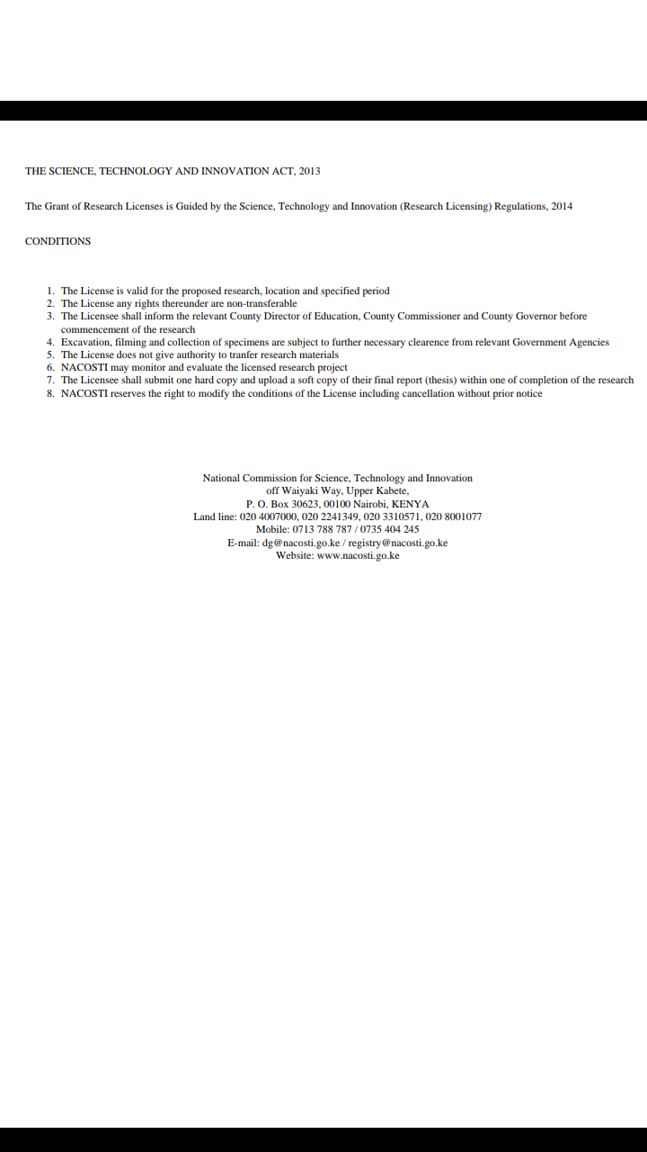

Appendix V: Publication Abstract Page
